*Buying A Home Soon? Get my Free Consumer Guide, “8 Secrets For Saving Thousands When Buying Your Home.” Call me right now at 636-970-0185 for details…*

# 

# March 2017

**St. Charles, MO**



## Inside This Issue…

**Hope Boosters…Page 1**

**Why Buy These Items When You Can Rent And Save Money?…Page 2**

3 Ways To Avoid Cavities Beyond Brushing…Page 2

Feeling Unmotivated To Clean?…Page 3

**Answer This Trivia Question and You Could Win A FREE CARWASH…….Page 4**

**What Should I Do To Make Sure My Home Sells?…Page 4**

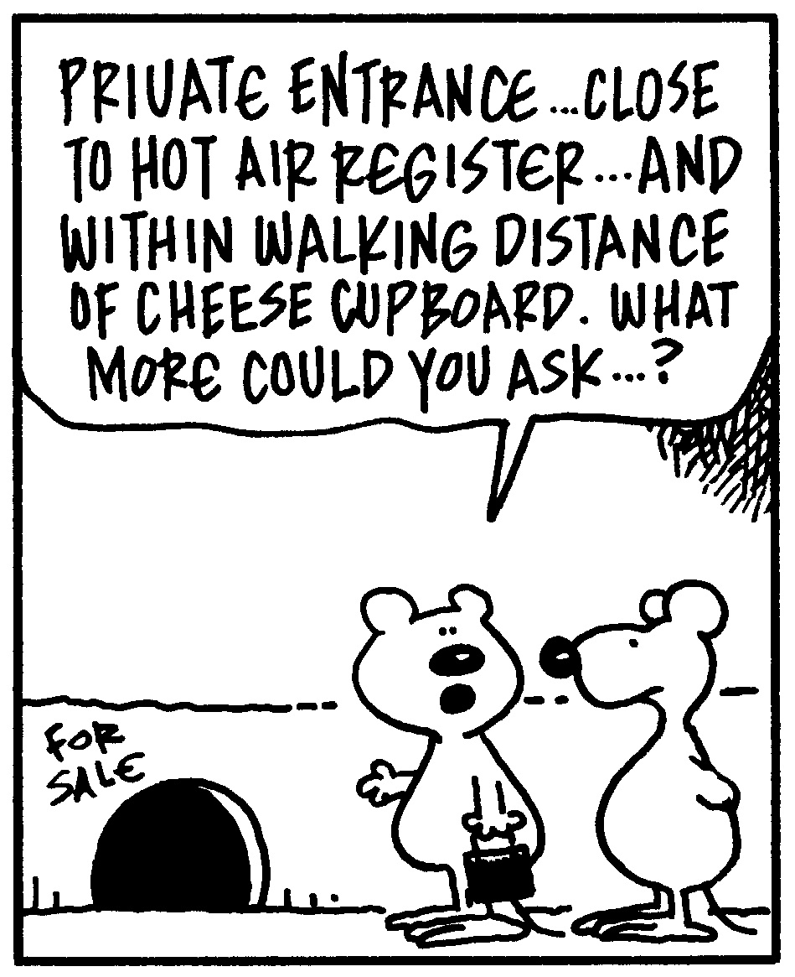

#### Selling St. Charles County News Tyme

### “Insider Tips For Healthy, Wealthy & Happy Living…”

**Joanna Horstmeier**

CDPE, CRS, E-pro, GRI,

### Broker Associate







**How To Find More**

**Hope In Your Life**

With a healthy dose of hope, people can power through stress, feel empowered to chase their dreams, and find a beacon of light when the going gets tough.

Research has shown that hopeful patients heal faster and hopeful employees are more satisfied with their jobs. Conversely, people who aren’t hopeful often feel sluggish and have little motivation and energy. So how can you amp up the hope in your life? Read on!

**Seek mastery:** Obtaining mastery provides a sense of empowerment and purpose, instilling a sense of hope. Expand your skill set by imagining what you want to achieve and make plans to reach those goals. Write down steps you need to follow to get the results you seek.

**Find role models:** If you suffer from a sense of hopelessness, find people who have overcome similar situations to yours. Learn from their experiences. Surround yourself with others who can help you through particularly trying times. If you don’t know anyone personally, check **projecthopeexchange.com** for support.

**Evaluate options:** Feeling trapped can stifle hope. During those times when you feel stuck, think about how you’ve handled similar situations in the past or how similar strategies from different situations can help you with this particular issue. Make a plan…even a few steps you can take right now can give you something concrete to focus on.

**Give hope to others:** Perform small acts of kindness. By doing so, you offer hope to others, and this can help boost your mood and outlook on life … and increase your feelings of hope in the process. The positive effects of acts of kindness build on each other, so make this a part of your daily routine instead of following a one-and-done approach.

**Thinking Of Buying A Home Soon?**

If you’re planning to buy a home in the next 6 months, you’ll want a copy of my Free consumer guide, “***7 Secrets For Saving Thousands When Financing Your Next Home****.”* My report will help you avoid frustrations and costly pitfalls when buying a home. Simply call me to get a free copy: **636-970-0185**

**Rent And Save Money**

People accumulate a lot of stuff throughout their lives, but they may only need certain things periodically. When that’s the case, rent instead of buying to save money and help the environment!

* **Lawn and power equipment:** Rent tillers, concrete saws, carpet cleaners, and more at your local home supply store. Most rentals are for a minimum of four hours.
* **Formal clothing:** If you need to dress up for one black-tie event, check out **renttherunway.com** or **lendingluxury.com**. Choose the perfect outfit for the night, and return it once it’s over. Rental prices are about one-third the retail price.
* **Party supplies:** Throw the event of the year, but don’t stress too much over all the things you need to purchase. Party equipment vendors can supply dishes, décor, and furniture, all delivered right to your door.
* **Recreational equipment:** Thinking of taking up golf or going camping? If you only participate in an activity occasionally, rent from local sports outfitters and save hundreds of dollars on gear that would otherwise collect dust in your garage.

**Word of the Month…**

Studies have shown your income and wealth are directly related to the size and depth of your vocabulary. Here is this month’s word, so you can impress your friends (and maybe even fatten your wallet!)…

**Augmented reality** (awg-ment-ed ree-al-i-tee) noun

**Meaning**: A live view of a physical, real-world environment that has been created with computer-generated sensory elements like sound, video, and graphics; also known as AR

**Sample Sentence:** Using augmented reality, the woman could see what her living room would look like with the couch she was thinking about buying.

**Dinner Time!**

According to a study commissioned by Giovanni Rana, an Italian pasta maker, the average dinner table in the United Kingdom is abuzz with activity. Over the life of a dinner table:

* It will endure 1,995 drink spills, 1,160 food stains, and 594 homework sessions.
* 1,101 meals will go unfinished.
* People will fall asleep 312 times.
* There will be 93 major announcements and 374 pieces of family news shared.

**Mountain-Top Trivia**

Despite common belief, Mt. Everest isn’t actually the highest spot on Earth – if “highest spot” is defined by being closest to the moon and stars. That title goes to Ecuador’s Mt. Chimborazo, which is the highest mountain above the Earth’s center because of the planet’s shape.

**Quotes To Live By…**

“To succeed in life, you need three things: A wishbone, a backbone, and a funny bone.”–Reba McEntire

“In the midst of winter, I found there was, within me, an invincible summer.”

–Albert Camus

“You can’t use up creativity. The more you use, the more you have.”

–Maya Angelou

Here’s A Free, Valuable Resource…

Now You Can Search The Home Market, Get Helpful Community Information, AND Receive Important Resources For Saving Time And Money When Buying Or Selling At [www.SellingStCharles.com](http://www.SellingStCharles.com)

**FREE Consumer Help Is Just A Phone Call Away**

Learn valuable secrets for saving thousands and avoiding costly mistakes when buying, selling or refinancing a home. Best of all, it’s FREE. Ask about my “**Insider’s Free Resources**” by calling me at: 636-970-0185

**Three Unexpected Ways To Prevent Cavities**

You’ve likely been told from a young age to brush your teeth in order to avoid getting cavities. But did you know you could do these three things to keep cavities at bay as well?

**1. Chew gum.** Sugar-free gum and candy that uses xylitol, a natural sugar substitute, may help fight cavities because bacteria cannot use it to grow and decay teeth.

**2. Drink with a straw.** Sip sugary beverages through a straw, and don’t let the straw touch your teeth.

**3. Eat cheese.** Research has shown that, after eating cheese, calcium levels in the mouth increase. This helps re-mineralize teeth and therefore prevent cavities from developing.

B

**Motivate Yourself To Clean**

Cleaning is one of those necessary evils that everyone has to tackle eventually. Don’t put this chore off for another day. Motivate yourself and get the job done!

* **Make a cleaning play list:** Turn your dirty work into a dance party. Throw together tunes that encourage you to move and sing along to get your mind off the task at hand. Or, treat yourself to a TV show that you’re only allowed to watch while you clean.
* **Let the light in:** Opening the blinds and curtains brightens up rooms – and your mood! In addition, it illuminates all the cruddy corners of your home, encouraging you to pull out that broom and dust rag.
* **Tackle a small job first:** Make your bed or clear off the dining room table, then go from there. Both significantly help clean up a portion of a single room effectively and quickly, and once you’ve done these things, it’s easy to keep going.
* **Cash in:** Use negative reinforcement to force yourself to clean. Using a website like **www.stickk.com**, set a goal to clean, and if the goal is not met, you’ll be forced to donate to a cause that is distasteful to you (such as to a political party you don’t align with).
* **Set aside time:** Just as you would schedule a doctor’s appointment or haircut, specifically reserve time to clean. Treat this like any other important activity that deserves time in your day so there are no conflicts interfering with the chore.

Brain Teaser…

You throw a ball as hard as you can. It doesn’t bounce off a wall, there is nothing attached to it, and no one else catches or throws it back to you … yet it comes right back to you. How is this possible?

*(See page 4 for the answer.)*

**Real Estate Question?**

Maybe you want to know how much your home is worth. Or maybe you just need a recommendation for a handyman, carpet cleaner or plumber…

Either way, I love hearing from all of my good friends and clients. And I’m happy to help answer questions you might have about anything relating to real estate or home-ownership.

If you have a question, tip or idea, call me at **636-970-0185**. I’m here to help!

**Flying High**

Collect frequent flyer miles and get the most bang for your traveling buck. Not sure how?

* **Keep track of miles.**  If you sign up for miles, keep an eye on expiration dates. If you accumulate miles through credit cards, flying, and using specific services, consider tracking miles with a service like **awardwallet.com**.
* **Call the airline directly to book.**  Many airline websites don’t show all affiliated partners, so call and ask about all available booking options.
* **Look beyond flights.** Many rewards programs also allow users to cash in for car rentals, hotel stays, and more.

**Websites For   
Organizational Help**

Stay organized and on task!

**www.calendar.google.com** – Note appointments and events, color code activities, and send and set reminders.

**www.getpocket.com** – Store online articles so you can read them later (even when you’re offline!).

**www.hootsuite.com** – Manage all your social media accounts in one place.

1

IMPORTANT NOTICE!!!!

As technology is more and more abundant these days, with folks using phones, computers, and tablets more and more, this will be our last printed issue of the newsletter. You will be able to access the ongoing issues by email or on my website [WWW.SELLINGSTCHARLESCOUNTY.COM](http://WWW.SELLINGSTCHARLESCOUNTY.COM).

To continue to receive this newsletter, please share your email address, and I will make sure you continue to receive all the special information. Please give me a call at 636-970-0185 or email me at

[Joanna@SellingStCharlesCounty.com](mailto:Joanna@SellingStCharlesCounty.com)

**Thanks For Thinking of Me!**

Did you know I can help you or any of your friends or family save time and money when buying or selling a home? Thanks for keeping me in mind with your referrals…and spreading the word about my services.

**Brain Teaser Answer:**

You throw the ball straight up in the air.

**Wholesale Money Savers**

Shopping in bulk can be a cost-effective way to save money on common items, but what’s *really* worth buying?

* Liquid detergents and soaps lose potency over time, so pass on them. However, powders have an unlimited shelf life.
* Check the expiration dates on beauty products and vitamins. If you can’t use it up in time, skip it.
* Perishable items like pretzels and chips may be cheaper in bulk, and are a good buy if you’ll get through them quickly.
* Staples like cereal, bread, canned goods, and soda may be similarly priced as the local grocery. Factor in available coupons and buy accordingly.

**Life Lesson:** The things that come to those who wait may be the things left by those who got there first!

**THANK YOU** for reading my personal newsletter. I wanted to produce a newsletter that has great content and is fun and valuable to you. Your constructive feedback is always welcome.

**AND…**whether you’re thinking of buying, selling or financing real estate, or just want to stop by and say “Hi,”  
 I’d love to hear from you…

**Joanna Horstmeier**

**CDPE – CRS – E-pro –GRI and**

**Broker Associate**

**Remax Results - 636-970-0185**

[***Joanna@SellingStCharlesCounty.com***](mailto:Joanna@SellingStCharlesCounty.com)

Disclaimer: The information contained in this letter is intended for informational purposes. It should not substitute as legal, accounting, investment, medical or other professional services advice. Always seek a competent professional for answers to your specific questions. This letter is not intended to solicit real estate properties currently for sale.

**“Who Else Wants To Win**

**A Free Carwash?”**

Last month’s question:

**What U.S. state has the most mountain ranges?**

a) Nevada b) Colorado c) California d) Washington

The answer is a) Nevada. The state has more than 150 mountain ranges. Its highest peak, Boundary Peak, is 13,146 feet high. So let’s move on to *this* month’s trivia question.

**What media personality used to be a speechwriter for Richard Nixon?**

a) Dr. Phil b) Oprah Winfrey c) Ben Stein d) Ellen DeGeneres

(Prize winners are limited to once per 6 month period.)

***Call Me At 636-970-0185 OR Email Me At*** [Joanna@SellingStCharlesCounty.com](mailto:Joanna@SellingStCharlesCounty.com)

***And You Could Be One Of My Next Winners!***

***Real Estate Corner…***

**Q. What do I need to do to sell my home?**

**A.** Here’s a list of important things you’ll need to do:

* **Set a realistic price.** Homes that are over-priced can linger on the market for months, while homes that are priced correctly usually sell faster and for the most money possible. Look at recent listings in your area and their actual sales prices, and visit homes for sale in the neighborhood before deciding on a price.
* **Get your home ready to show.** Clear out clutter, freshen paint, and clean up landscaping. Remember buyers notice everything!
* **Review the promotional plan of a Home Marketing Expert.** An experienced REALTOR® can help you sell quickly by advertising your home in more ways than simply creating a MLS description. Plus, they can help you avoid costly mistakes on contracts and disclosures required by law to sell real estate.

Want to learn more? Ask for my Free Consumer Report called   
***“7 Insider Tips to Net More Money Selling Your Home.”*** I’ll send a copy right over to you.

Do you have a real estate question you want answered? Feel free to call me at <<**888-8888**>>. Perhaps I’ll feature it in my next issue!