*WARNING: Don’t even think of selling your home without my Free Consumer Guide titled, “How To Avoid 7 Costly Mistakes When Selling Your Home.” Call me right now at 636-970-0185 to learn more…*



# April 2017

**St. Charles, MO**

## 

## Inside This Issue…

**Foster Better Work Relationships…Page 1**

**In Shape And You Didn’t Even   
Know It!…Page 2**

**Throwing A Memorable Backyard Wedding…Page 3**

**Bee Safety Tips…Page 3**

**Answer This Trivia Question and You Could Win a FREE Pizza…...Page 4**

**Who Determines The Value Of My Home?...Page 4**

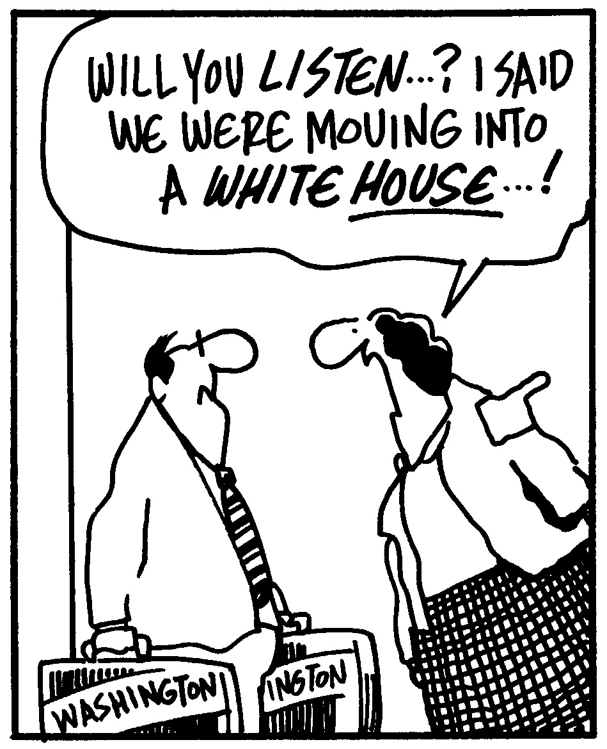



#### Selling St. Charles County News Tyme

### “Insider Tips For Healthy, Wealthy & Happy Living…”

**Joanna Horstmeier**

CDPE, CRS, E-pro, GRI,

### Broker Associate







**6 Ways To Improve Your   
Work Relationships**

If you are like most Americans, you’ll spend about one-third of your life working. And if you’re going to spend so much time at work, wouldn’t it be ideal if you liked your colleagues? There is good reason to get along with co-workers: Liking other employees consistently ranks among the highest factors in determining job satisfaction. This isn’t always easy, however. If some of your work relationships could use a little sprucing up, try these tips:

1. **Respect time.** Avoid hovering around your colleagues’ work areas if they’re on the phone or speaking with someone else, and respect their professional/personal life balance by keeping work issues at work.
2. **Avoid gossip.** Office politics and the rumor mill can run rampant, and the best thing you can do is to avoid any conversation that is irrelevant to your job. You never know whom you will have to work with – or for – in the future, so do your best to remain professional to everyone.
3. **Be polite.** The Golden Rule of doing unto others as you would have them do unto you goes a long way in a professional setting. Say hello and thank you, smile, hold doors open for others, and clean up after yourself.
4. **Show concern.** It is not your job to solve personal problems, but keep in mind your co-workers are people too. Be mindful that others may be having a bad day or issues beyond the boardroom. If you feel comfortable, it’s okay to check in to make sure everything is alright.
5. **Welcome the newcomers**. Do you remember your first awkward day of work? Make someone else’s first day on the job easier by smiling and introducing yourself.
6. **Follow up and communicate.** Simple communication goes a long way in helping to facilitate good relations and clear up misunderstandings. Make yourself approachable so others feel they can discuss work-related projects with you. Managers need to set clear expectations with their employees so there is no question about what is expected from each person.

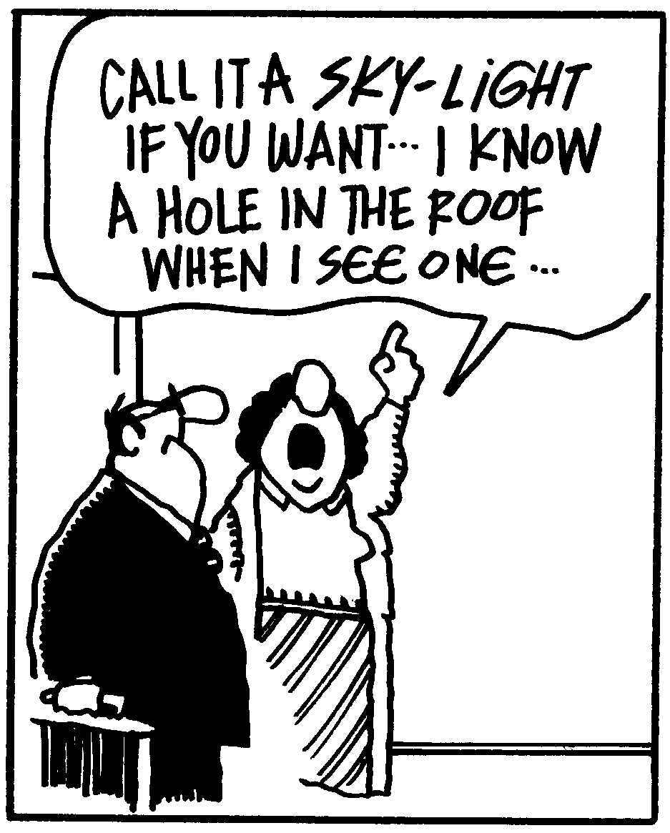

# Learn How To Maximize The Value Of Your Home

Did you know there’s a free consumer report showing what to fix to net the most value for your home? It’s called “***Make Your Home Show Like A Model Without Breaking The Bank***” and it’s an essential guide to homeowner profits. You can get a free copy by calling me at…**636-970-0185**

**Word of the Month…**

Studies have shown your income and wealth are directly related to the size and depth of your vocabulary. Here is this month’s word, so you can impress your friends (and maybe even fatten your wallet!)…

**C-suite** (see-sweet) noun

**Meaning:** a term that collectively refers to a company’s most senior executives, derived from the fact that most job titles start with the letter C

**Sample Sentence:**  The C-suite is out of the office at a shareholders’ meeting today.

**Have A Laugh…**

If you really want to slap someone, go for it! Just make sure you yell “Mosquito!” as you do it.

**Hidden Travel Costs**

You’ve budgeted for an airplane ticket, hotel room, and activities for your next vacation, but did you remember to factor in these unexpected costs as well?

* Boarding for your pets or a pet-sitter ($20-$50/night).
* In-flight wifi if you need to login ($5-$15).
* International credit card transaction fees (1%-3% of the purchase price).
* Departure tax, if applicable and it’s not already included in the ticket price ($5-$40).

**Springing Season**

In the 14th century, the term “springing time” was used to describe the time when plants were growing. By the 16th century, the season was simply called **spring.**

**Quotes To Live By…**

“Quiet people have the loudest minds.”

–Stephen King

“Don’t let your happiness depend on something you may lose.”

–C.S. Lewis

“A father is a man who expects his son to be as good a man as he meant to be.”

–Frank A. Clark

**You Might Be Fitter**

**Than You Think**

Blame the media, Photoshop, the feats of professional athletes, or your own unrealistic expectations, but the truth is you’re probably not that out of shape. In fact, you may just be fitter than you think – and I can prove it!

**You stand and sit.** Active people feel the need to get up and move around throughout the day. Getting in and out of a car involves basic squat movements, and you should be able to do this without pain.

**You constantly carry stuff.** Whether you’re picking up and carrying children or shouldering a massive bag to and from work, those pounds add up to a healthy dose of weightlifting!

**You recover quickly.** Take a short jog, try a few squat exercises, or just walk at a steady pace for a while. Are you tired and worn out, or could you endure a bit more? A healthy recovery time is a good indicator of physical fitness.

**You do household chores.** Carrying laundry down the stairs requires balance. Navigating several tasks in the kitchen while avoiding dropping, burning, or falling is proof of coordination and dexterity.

**You take the stairs.** If you can walk or run up and down stairs without feeling lightheaded or out of breath, you’re probably in decent aerobic shape.

**You crave healthy habits.** It’s a good sign if you seek out exercise simply because it makes you feel good – and you get extra points if you vary your workouts, which offers different benefits to different muscle groups. Ditto if you prefer to eat healthily as well.

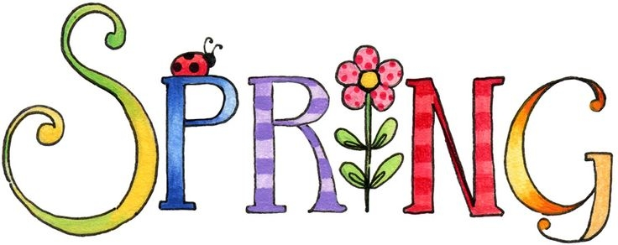

Brain Teaser…

Why is the number 8,549,176,320 unique?

*(See page 4 for the answer.)*

**What’s My Home Worth?**

If you want to know your home’s current value, I will gladly conduct a ***Maximum Value Home Audit***. Request this “no charge” in-depth home value analysis by calling me at: **636-970-0185**.

**What Belongs In A Go-Bag?**

Each family should have an emergency kit, or go-bag, ready at a moment’s notice. What goes inside? (Check with **FEMA.gov** for a thorough packing list.)

**For nourishment:** Non-perishable food, can opener, and water.

**For safety:** Battery-powered or hand-crank radio, pliers, whistle, flashlight and batteries, and a cell phone charger.

**For health:** First aid kit, dust mask, moist towelettes, garbage bags, and plastic ties.

**For individual needs:** Three days to a week’s worth of medication, formula and diapers for babies, extra contacts and glasses, and pet food.

**Moonbows 101**

Moonbows are rainbows created by moonlight. The conditions have to be just right for them to be visible. The moon must be full or almost full, the sky must be very dark (no moonbows in cities) and the moon must be low in the sky.

**Fact-Checking Websites**

What is true and what is false? Use these websites to check the facts.

**www.snopes.com** – Debunking or confirming common urban legends, folklore, and rumors.

**www.reporterslab.org/fact-checking** – Database of global fact-checking sites. The map makes it easy to find organizations around the world.

**www.politifact.com** – Political fact checking of statements made in U.S. politics – including Congress, the White House, lobbyists, and interest groups, which are rated on the Truth-o-Meter.

**How To Throw A**

**Backyard Wedding**

Are there wedding plans in your near future? Save a chunk of change and throw a backyard wedding everyone will remember.

• **Match the guest list with accommodations.** Don’t invite more people than your space can comfortably accommodate. Once the guest list is confirmed, assess what furniture, dishes, and equipment (like grills or coolers) you need so everyone’s needs are met. Rent to save money.

• **Keep it casual.** Of course, the sky is the limit when it comes to dream weddings, but backyard bashes work well when they’re a bit on the casual side. Centerpieces can be DIY and flowers can be cut from the garden.

• **Light it up.** If you’re hosting an evening or night wedding, make sure there’s sufficient lighting throughout the yard. String lights can help achieve this – and add to the ambience!

• **Bug off.** Keep mosquitoes and other pesky critters at bay by getting rid of standing water in the weeks leading up to the wedding, turning on fans, and offering guests bug wipes if appropriate.

**Would You Like To Know How Much Your**

**Neighbor’s Home Listed Or Sold For?**

Maybe you’re just curious. Or maybe you want to know how much your home is worth. Either way, I can help…with no “sales pitches” or run-arounds. Call me at 636-970-0185 and I’ll give you all the facts.

**Stay Safe Around Bees**

Being attacked by bees, wasps, and hornets is not common, but they are responsible for 58 deaths every year, according to the Centers for Disease Control. Though the average adult (if not allergic) can theoretically tolerate more than 1,000 stings, it’s best to avoid being stung altogether. A swarm of bees can happen quickly and without provocation, but there are things you can do to minimize potential harm.

* Maintain diligence when doing yardwork. Keep kids and animals inside when using lawn mowers, hedge clippers, and other similar tools in case you accidentally disturb a nest.
* Check for bee nests regularly in water meter boxes, flower pots, trees, and shrubs. If you find one, call a pest control company to remove it.
* If you encounter bees and they are undisturbed, do not move excessively. Back out of the situation slowly.
* If you are swarmed, run as fast as possible in a straight line. Cover your head. Do not flail your arms or swing at the bees, and do not jump into water. Ideally, you should seek shelter in something that closes completely, like a building or car.

**Thanks For Thinking of Me!**

Did you know I can help you or any of your friends or family save time and money when buying or selling a home? Thanks for keeping me in mind with your referrals…and spreading the word about my services.

**Brain Teaser Answer:**

It contains every number zero through nine in alphabetical order.

**3 Easy Self-Care Tips**

In order to remain productive, focused, and able to care for others, it’s important to care for yourself first.

1. **Stay hydrated.** Even mild dehydration can be detrimental to mood and mental cognition, according to University of Connecticut’s Human Performance Laboratory researchers. Drink about a half gallon of water a day.
2. **Care for plants.** Being around plants can increase memory retention up to 20%, according to a University of Michigan study.
3. **Get enough sleep.** Adequate sleep enhances learning and problem-solving skills, and helps you pay attention and make decisions. The average adult needs 7-8 hours per day.

**THANK YOU** for reading my

personal newsletter. I wanted to produce a newsletter that has great content and is fun and valuable to you. Your constructive feedback is always welcome.

**AND…**whether you’re thinking of buying, selling or financing real estate, or just want to stop by and say “Hi,” I’d love to hear from you…

**Joanna Horstmeier**

**CDPE – CRS – E-pro –GRI and**

**Broker Associate**

**Remax Results - 636-970-0185**

[***Joanna@SellingStCharlesCounty.com***](mailto:Joanna@SellingStCharlesCounty.com)

Disclaimer: The information contained in this letter is intended for informational purposes. It should not substitute as legal, accounting, investment, medical or other professional services advice. Always seek a competent professional for answers to your specific questions. This letter is not intended to solicit real estate properties currently for sale.

**“Who Else Wants To Win**

**A Free Pizza??”**

Congratulations to last month’s Trivia Contest Winner:

Dwight Paulus from St. Charles!!

Who will be out next winner?

(Prize winners are limited to once per 6 month period.)

**What media personality used to be a speechwriter for   
Richard Nixon?**

a) Dr. Phil b) Oprah Winfrey c) Ben Stein d) Ellen DeGeneres

The answer is c) Ben Stein. Ben Stein is an American writer, lawyer, actor and commentator who had success as a speechwriter for both Nixon and Gerald Ford. So let’s move on to *this* month’s trivia question.

**What is the name of the gum company Fruit Stripe’s zebra mascot?**

a) Yipes b) Willy c) Zippy d) Chester

***Call Me At 636-079-0185 OR Email Me At Joanna@SellingStCharles.com***

***And You Could Be One Of My Next Winners!***

***Real Estate Corner…***

**Q. Who determines the value of my home?**

**A.** When you’re ready to sell your home, you may be wondering what price to ask and how much you’ll get. There are two main people who determine the initial and final price of a home.

1. **Appraisers** will look at recent comparable sales. You can look online and see what homes have sold for in the last 6-12 months. Sold prices are a stronger indication than “asking” prices. How similar are the homes that sold to your home in size and features?
2. **Buyers** will make an offer based on their ability to pay and how much they like your home compared to other homes for sale.

Did you notice I left someone important out? What about you, the

seller? Only the market determines the final price at which your home will sell, however, as the seller you can influence how *long* it will take to sell by offering a reasonable price.

To learn more, ask for my Free Report called ***“6 Steps For Selling Your Home For TOP DOLLAR.”*** I’ll send a copy right over to you.

Do you have a real estate question you want answered? Feel free to call me at 636-970-0185. Perhaps I’ll feature it in my next issue!