*WARNING: Don’t even think of selling your home without my Free Consumer Guide titled, “How To Avoid 7 Costly Mistakes When Selling Your Home.” Call me right now at 636-970-0185 to learn more…*



# October 2017

**St. Charles, MO**

## 

## Inside This Issue…

**Five Tips For Charitable Giving…Page 1**

**Sideline Workout Boredom…Page 2**

**Relationships With Adult Siblings…Page 3**

**Moving? Read This First!…Page 3**

**Answer This Trivia Question and You Could Win a FREE Car Wash...Page 4**

**I’m Worried About Possible Foreclosure on My House- What Can I Do To Avoid It?...Page 4**

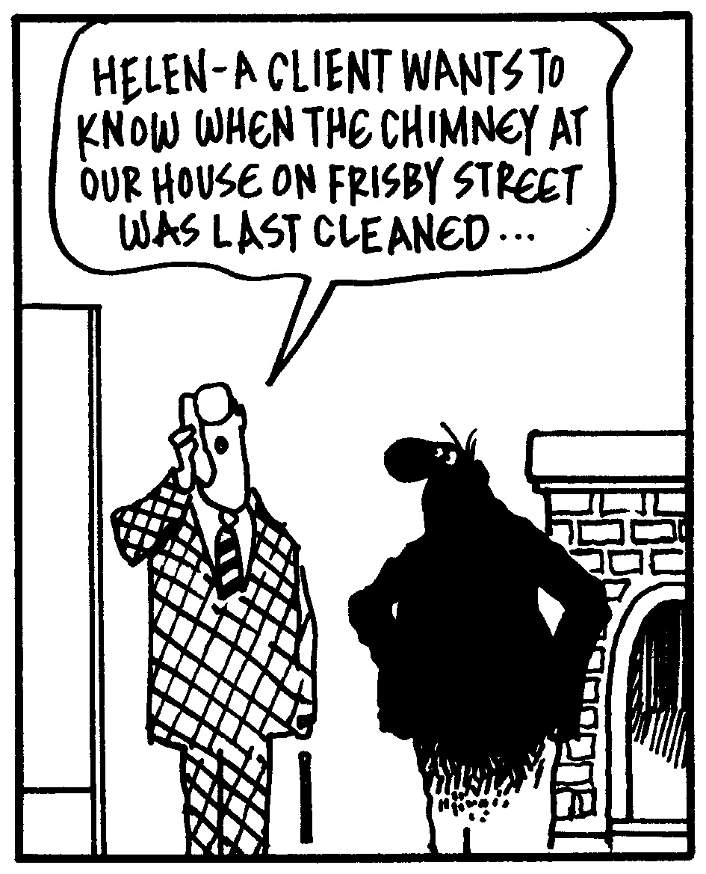



#### Selling St. Charles County News Tyme

### “Insider Tips For Healthy, Wealthy & Happy Living…”

**Joanna Horstmeier**

CDPE, CIPS, CRS, E-pro, GRI,

### Broker Associate



**Smart Charitable Giving For Savvy Donors**

‘Tis the season when many people start thinking about charitable giving for the holidays. There are a lot of organizations clamoring for your hard-earned money. Use these handy tips to ensure you’re making the best decisions when it comes to doling out charitable gifts.

* **Seek out an established charity.** Especially in times of crisis or disasters, charities seem to pop up out of nowhere in response. A good check that an organization is established is that it has at least been approved for tax purposes as a non-profit. Ensure charities are registered as tax-exempt with 501(c)(3) status (check **IRS.gov** for “EO Select Check” to verify that an organization is registered as exempt).
* **Research the charity in question**. Consider your gift a financial investment and conduct due diligence before deciding how to invest it. Check out sites like **charitynavigator.org** and **guidestar.org**, which have done a lot of the work by vetting organizations based on criteria like financial stability, funding, transparency, and ethical practices.
* **Give an unrestricted donation.** Once you’ve established the organization handles its funds well, consider giving money that isn’t earmarked for a specific effort. This gives the charity freedom to decide how to use the gift (and lets it decide what is most helpful).
* **Look for a matching gift.** Find out if your place of employment, church, social club, or a neighborhood business is currently offering to match financial gifts to certain charities. Taking advantage of a matching effort helps the donation go even further.
* **Consider tax benefits.** Generally, donations of cash and property to qualified non-profit organizations equaling $250 or more are tax- deductible. These donations must be made no later than   
  December 31 of the year in which the deduction is claimed.



**Thinking Of Buying A Home Soon?**

If you’re planning to buy a home in the next 6 months, you’ll want a copy of my Free consumer guide, “***7 Secrets For Saving Thousands When Financing Your Next Home****.”* My report will help you avoid frustrations and costly pitfalls when buying a home. Simply call me to get a free copy: **636-970-0185**

**Word of the Month…**

Studies have shown your income and wealth are directly related to the size and depth of your vocabulary. Here is this month’s word, so you can impress your friends (and maybe even fatten your wallet!)…

**Technoference** (tek-no-fear-ence) noun

**Meaning:** snubbing a person in favor of any type of technology

**Sample Sentence:**  Their relationship was suffering from technoference when he kept checking his text messages during dinner instead of focusing on the conversation at hand.

**Smart Refrigerator Storage**

* **Well-preserved foods** (pickles, condiments) on the door (the warmest area).
* **Raw ingredients** (eggs, meat) on a lower shelf (the coldest area).
* **Produce that is low moisture** (apples, grapes, pears) in a crisper drawer with the window open (humidity control set to low) to slow down rot.
* **Produce that needs to retain moisture** (lettuce, mushrooms, peppers) in a drawer with the window closed (humidity set to high) to prevent wilting.
* **Prepared foods** **and leftovers** on the top shelf for easy access.
* **Bonus tip:**  Produce should be stored away from raw meat and dairy to avoid contamination.

**Stop Losing DIY Tools!**

After assembling DIY furniture, don’t toss the Allen wrench or other specialized tools in a drawer or the garbage. Instead, tape it to the back or underside of the item so you can easily retrieve it when screws need tightening or it needs disassembling.

**Quotes To Live By…**

“Every child is an artist. The problem is staying an artist when you grow up.”

–Pablo Picasso

“Honesty is a very expensive gift. Don’t expect it from cheap people.”

–Warren Buffet

“There is nothing that wastes the body like worry.”

–Mahatma Gandhi

**How To Fight Fitness Fatigue**

Love it or hate it, working out is one of those things everyone should make a regular part of their lives. What might start out as a sense of fun and excitement when tying up running shoes or stepping into an aerobics class can eventually turn into a sense of boredom and downright drudgery. It doesn’t have to, though - when you incorporate these elements:

**Try something new.** Variety is the spice of life, and this definitely holds true for working out. For those who tend to stick to walking or running, signing up for a martial arts class or joining a recreational volleyball league can add that special something to a weekly workout routine. Never tried ballroom dancing before? Now’s the time!

**Find a sense of purpose.** Signing up for something with an end goal such as a weight-lifting contest, swimming race, or sprint triathlon offers a good reason to get to the gym. If additional motivation is needed, choose to train and raise money for a specific cause.

**Make it a group effort.** Working out with other people is good for motivation – and it’s more fun! For those who have historically trained for solo sporting events, finding a group of friends and joining a team adventure activity or long-distance relay race can put that sense of fun back into a fitness regimen.

**Get outside.** Avoid the treadmill and stationary bike, and add some variety to a workout by going for a jog or bike ride outside. Vary the route, speed routine, and time of day to keep things interesting. Or, instead of taking a group class at the gym, find one that meets in a local park and incorporates the jungle gym, natural obstacles, and other class members to challenge fitness skills.



Brain Teaser…

I exist only when there is light, but direct light kills me. What am I?

*(See page 4 for the answer.)*

**What’s My Home Worth?**

If you want to know your home’s current value, I will gladly conduct a ***Maximum Value Home Audit***. Request this “no charge” in-depth home value analysis by calling me at: **<<888-8888>>**.

**Stress-Free Mantras**

Feeling stressed? Breathe deeply and repeat one of these mantras to yourself:

* “Smiling brings me joy.”
* “Let it be.”
* “I forgive myself.”
* “It’s not the end of the world.”
* “Serenity now. Insanity later.” –

Frank Costanza

**U.S. Post Offices Of Note**

* Highest: Alma, Colorado (10,578 feet above sea level)
* Lowest: Death Valley, California (282 feet below sea level)
* Oldest: Hinsdale, New Hampshire (in the same building since 1816)
* Smallest: Ochopee, Florida (61.3 square feet)
* Easternmost: Lubec, Maine
* Westernmost: Adak, Alaska

**Networking Know-How**

For the best professional networking opportunities, Vanessa Van Edwards, author of “Captivate,” recommends avoiding the “start zone” (where people are checking in) and the “side zone” (near the food and bathroom). Stick to the “social zone,” usually around the bar, where people are relaxed.

**Movie Websites**

Not sure what movie to watch? Use these to help find the perfect film.

**www.AGoodMovieToWatch.com** – Search by mood or genre … or take a chance and choose a random flick.

**www.tastedive.com/movies** – Type in the name of a film you like and get recommendations.

**www.imdb.com** – Suggestions based on theme plus editor recommendations.

**Getting Along With Adult Siblings**

If you have siblings, count yourself lucky. These relationships are the longest-lasting family ties you’ll have. This can be tough for those who had rough sibling relationships growing up, but a recent study found two-thirds of people said a brother or sister was one of their best friends. It’s never too late to turn that special family relationship into one of your most treasured – or keep it from going stale.

People spend lots of effort improving friendships and romantic relationships, but a brother or sister may outlast all of those relationships. **Don’t take a sibling relationship for granted.** Research by West Virginia University shows people are more verbally aggressive with siblings than anyone else. Being aware of this and **actively offering affectionate support** goes a long way to strengthen familial ties.

Also, don’t compare your sibling relationships with those of other people. These are your unique relationships, so **shake off expectations**. Siblings may not unconditionally confide in or spend every holiday with you, and that’s okay. Instead, **enjoy the time spent together and conversations you do have.** Focus on the good instead of what could be.

**Would You Like To Know How Much Your**

**Neighbor’s Home Listed Or Sold For?**

Maybe you’re just curious. Or maybe you want to know how much your home is worth. Either way, I can help…with no “sales pitches” or run-arounds. Call me at 636-970-0185 and I’ll give you all the facts.

**Tips For an Easy Move**

Moving out of a home can be undeniably stressful. Make things as easy as possible on yourself.

* **Schedule a donation pickup.**  Don’t waste time driving to a donation center. Contact local nonprofits (or use a service like **donationtown.org**) for pickup so you never have to leave home.
* **Pick a quiet moving day.** Weekends are the busiest days to move. Choosing another day of the week may save money with a moving company.
* **Double down with cloth items.** Wrap breakables in clothing and linen. Pack glasses and stemware in clean socks.
* **Label the sides of boxes.** That way you don’t have to move the boxes to read what’s written on them.
* **Use dresser drawers as boxes.**  Wrap tightly with plastic wrap and they’re ready to go!
* **Photograph electronics before dismantling.** It will be easier to reattach all the cords and wires in your new home.

**Thanks For Thinking of Me!**

Did you know I can help you or any of your friends or family save time and money when buying or selling a home? Thanks for keeping me in mind with your referrals…and spreading the word about my services.

**Brain Teaser Answer:**

A shadow

**Introduce Yourself To Fido**

Get off on the right paw by introducing yourself the right way to a new dog.

1. Approach and make conversation with the owner. Ignore the dog.
2. Ask for permission before touching.
3. Position yourself next to the dog and let it approach you.
4. Avoid eye contact.
5. Let the dog sniff a closed fist.
6. If the dog seems okay with this, pet on the shoulder, chest, or neck but not the head or above the dog.
7. If it backs away, the dog is not interested in being petted by you.

**Swear By It**

What is the best way to get an 80-year-old lady to say the F word?

Get another 80-year-old lady to yell “bingo!”

**THANK YOU** for reading my

personal newsletter. I wanted to produce a newsletter that has great content and is fun and valuable to you. Your constructive feedback is always welcome.

**AND…**whether you’re thinking of buying, selling or financing real estate, or just want to stop by and say “Hi,” I’d love to hear from you…

**Joanna Horstmeier**

**CDPE - CIPS – CRS – E-pro –GRI**

**And Broker Associate**

**Remax Results - 636-970-0185**

[***Joanna@SellingStCharlesCounty.com***](mailto:Joanna@SellingStCharlesCounty.com)

Disclaimer: The information contained in this letter is intended for informational purposes. It should not substitute as legal, accounting, investment, medical or other professional services advice. Always seek a competent professional for answers to your specific questions. This letter is not intended to solicit real estate properties currently for sale.

**“Who Else Wants To Win**

**A Free Car Wash???”**

Must have been a tough question last month. We had no winners ☹

Let’s see who is up to the challenge this month!

**Remember Roy Rogers and Dale Evans? Roy's horse was named Trigger. What was Dale's horse's name?**

a) Daisy b) Scout c) Buttermilk d) Tulip

The answer is c) Buttermilk. So let’s move on to *this* month’s trivia question.

**What does a red front door mean to homeowners in Scotland?**

a) New baby in the family b) New empty nesters c) First-time home buyers d) Paid off the mortgage

***Call Me At 636-970-0185 OR Email Me At Joanna@SellingStCharlesCounty.com***

***And You Could Be One Of My Next Winners!***

***Real Estate Corner…***

**Q. What experts should I talk to if my home is about to go into foreclosure?**

**A.** Avoid scammers, and talk to one or more of these professionals:

* **Your REALTOR®** will help you review your options.
* **A Foreclosure Counselor** will help you evaluate your current financial situation and serve as an advocate with your bank, free of charge.
* **A Tax Expert** will advise you if you do a short sale or deed-in-lieu of foreclosure since forgiveness of debt may be considered taxable income.
* **A Credit Counselor** can help you develop a plan to avoid future financial difficulty as well as help you repair your credit score.
* **An Attorney** can help you if your lender has filed a foreclosure lawsuit.

For more information on avoiding foreclosure, call and ask for my Free Consumer Report called ***“Options To Avoid Foreclosure.”***  I’ll be glad to send a copy right over to you.

Do you have a real estate question you want answered? Feel free to call me at 636-970-0185. Perhaps I’ll feature it in my next issue!