*If you’re thinking about selling your home soon, request my Free Consumer Guide, “7 Insider Tips To Net More Money Selling Your Own Home.” Call me right now at 636-970-0185 for details…*

# 

# November 2017

**St. Charles, MO**



## Inside This Issue…

**Home Safety Tips For Babies Or Senior Citizens…Page 1**

**Plan Now For A Financially Secure Retirement…Page 2**

Wedding Registry Items To Avoid…Page 2

Long Live Our Pets…Page 3

**Answer This Trivia Question and You Could Win ……a FREE Car Wash...Page 4**

**How Do I Find the Right House For Me- at the Right Price?…Page 4**

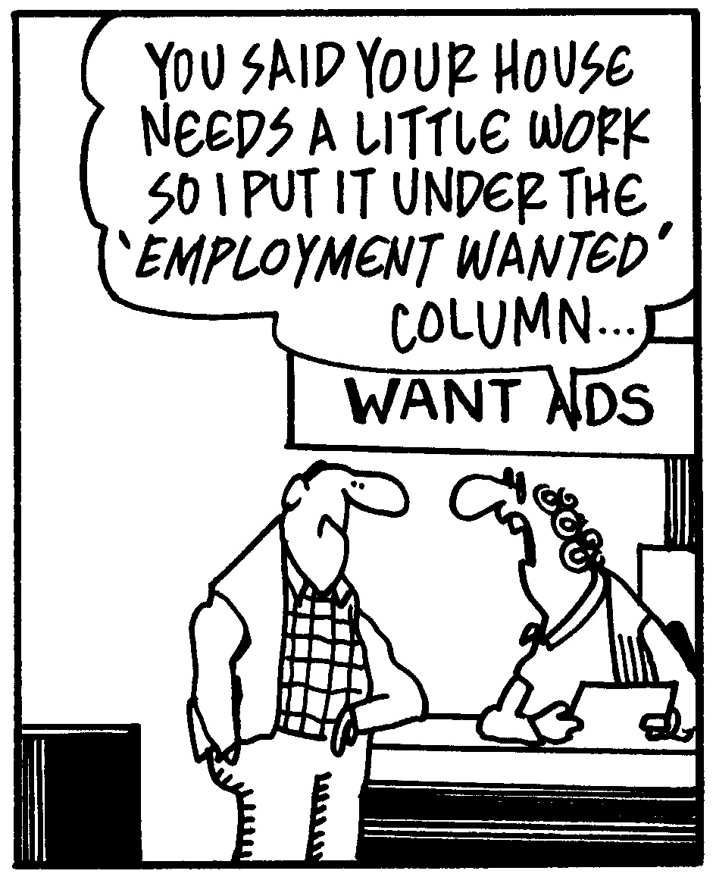

#### Selling St. Charles County News Tyme

### “Insider Tips For Healthy, Wealthy & Happy Living…”

**Joanna Horstmeier**

CDPE, CIPS, CRS, E-pro, GRI,

Broker Associate 





**How To Make A Home Safe For Babies And Seniors**

A happy home is a safe home. If there are babies or senior citizens living in yours, there are several things you can do to make it as safe as possible.

*Babies:*

* Use safety gates at the top and bottom of staircases.
* Cover electrical outlets with plastic caps.
* Tightly close containers with cleaning supplies, detergents, and paint, and move them to top cabinet shelves. Move sharp objects and suffocation hazards to top drawers.
* Secure the oven door and refrigerator with appliance latches.
* Add cushioned guards to sharp-cornered surfaces.
* Move furniture away from windows.
* Use doorstops and door holders to prop doors open.
* Mark sliding glass doors and other expanses of glass with colorful stickers.

*Seniors:*

* Ensure flooring has a good grip. Remove small rugs and other tripping hazards, and place carpet or rubber flooring over slippery floors.
* Remove electrical cords or cables that lie across pathways.
* Place light switches near room entrances, and place motion-sensor nightlights around the home.
* Install handrails in the bathroom and along stairways.
* Keep fire extinguishers easily accessible throughout the home.
* Replace the bathtub with a walk-in shower, and place a suction-bottomed bathroom mat in the shower.
* Place commonly used items in eye-level cabinets and cupboards so they can be easily reached.

**Thinking Of Selling Your Home Soon?**

Don’t attempt to sell your home without my Free Consumer Guide, “***6 Steps For Selling Your Home For Top Dollar****.”* My exclusive report will give you all the facts for a fast, top dollar sale. Just call **636-970-0185** anytime, 24 hours, and I’ll rush a copy out to you for free.

**Overcoming Retirement**

**Financial Fears**

You’ve worked tirelessly your entire life, and retirement is your time to finally and fully enjoy that hard-earned rest and relaxation. Unfortunately, not being able to afford retirement is a fear many people have. Get ahead of the game so you can rest easy.

* Start saving now, at your current age. Establish a monthly budget that includes tucking money away for retirement.
* Stick to the retirement plan. Do not withdraw money early for expenses if you have any other options.
* Avoid borrowing money, and keep debt to a minimum.
* Use a 401(k) plan to boost retirement savings. These plans allow funds to be invested directly from a paycheck before they’re subject to taxes.
* Take advantage of company matching opportunities for retirement contributions.

**Word of the Month…**

Studies have shown your income and wealth are directly related to the size and depth of your vocabulary. Here is this month’s word, so you can impress your friends (and maybe even fatten your wallet!)…

**Kidult** (kid-ult) noun

**Meaning**: a grown-up with tendencies to act like or engage in entertainment made for kids

**Sample Sentence:** Instead of looking for a full-time job, the kidult spent his days playing video games.

**Car Rental Ploys**

Beware these shady car rental tactics before driving away.

* **“Do you want an upgrade?”** Before saying yes, clarify whether there is an additional cost.
* **“Would you like additional insurance?”** The car insurance you already have may cover your needs. Research your policy before arriving at the rental desk.
* **“Do you want a prepaid fuel option/fuel-efficient car/other upgrade?”** If you aren’t interested, say so, even if you get pushback.

**Cloudy Or Sunny?**

Weather apps all have different forecast information – but why? Just like weather reports on TV, meteorologists all have the same set of raw data, but they must process that data and make judgment calls based on their own prediction in each given situation.

**Quotes To Live By…**

“Believe you can and you’re halfway there.”

–Theodore Roosevelt

“I’m just a seasonal guy. Basketball, football, baseball, boxing, golf. Give it to me all the time.”

–Jerry Ferrara

“The two most important days in your life are the day you are born and the day you find out why.”

–Mark Twain

Here’s A Free, Valuable Resource…

Now You Can Search The Home Market, Get Helpful Community Information, AND Receive Important Resources For Saving Time And Money When Buying Or Selling At **www.SellingStCharlesCounty.com**

**Avoid These**

**Wedding Registry Items**

Whether you’re planning your own wedding or shopping for someone else’s, gifting is part of the game. The best gifts are useful and thoughtful. Others, while good in theory, are best avoided.

**In the kitchen:** Avoid appliance fads like ice cream makers and fondue kits that take up space but aren’t used frequently. Instead of large serving platters, opt for medium-sized or modular pieces. Skip fine crystal and china.

**In the bedroom:** Does the couple need more bed linens? One set of linens is sufficient, especially if the family situation is likely to change and beds will be added or removed in the house.

**In the bathroom:** Monogrammed towels – or any other personalized items – are expensive and unnecessary. Also, avoid gifting cleaning items like mops or brooms.

**In general:** People are generous, but if it’s your wedding avoid asking for big-ticket items like a new hot tub or full-blown outdoor kitchen.

B

**Help Your Pet Live A Long And Healthy Life**

Most pet owners would say that pets are important members of the family. We welcome them into our lives knowing we’ll most likely outlive them- but we can help them have the best possible life. Here are some tips for giving your critter a long, happy life:

* **Maintain a healthy weight.** Feed pets the proper type and amount of food. Avoid feeding fatty human foods to your furry friends.
* **Exercise regularly.** Dogs need regular walks every day, and time to run around. Indoor cats live longer than outdoor cats, but they should have stimulating toys and room to play and exercise too.
* **Schedule regular vet visits.** Regular health screenings (at least once a year for healthy adult animals) allow vets to detect and manage diseases early. Keep vaccinations updated.
* **Keep teeth clean.** Tartar, gingivitis, plaque, and other problems with teeth and gums can lead to other health problems. Brush dogs’ teeth at least a couple times a week. Try making your own toothpaste with coconut oil and baking soda, and your dog will enjoy his brushing time. The Veterinary Oral Health Council publishes a list of accepted oral health products to help with dental care as well (**http://www.vohc.org/accepted_products.htm**).
* **Note behavioral changes.** If pets aren’t following their normal routines, this may be a sign that something isn’t right. Don’t wait too long before checking with a vet about abnormal behavior.
* **Chill out.** Even pets need time and space on their own, so make sure they have at least a couple hours a day to relax.

Brain Teaser…

A blue house is made from blue bricks. A yellow house is made from yellow bricks. A red house is made from red bricks. What is a green house made from?

*(See page 4 for the answer.)*

**Real Estate Question?**

Maybe you want to know how much your home is worth. Or maybe you just need a recommendation for a handyman, carpet cleaner or plumber…

Either way, I love hearing from all of my good friends and clients. And I’m happy to help answer questions you might have about anything relating to real estate or home-ownership.

If you have a question, tip or idea, call me at **636-970-0185**. I’m here to help!

**Passport Facts**

How much do you know about your passport? The International Civil Aviation Organization has outlined the following rules about these little books:

* Made of a material that bends rather than creases.
* Stable in temperatures between 14F-122F degrees.
* Readable in humidity conditions between 5%-95%.

However, there are no stipulations about typeface, type size, font, and cover color, yet all countries have chosen shades of red, blue, green, and black for cover colors.

**Blue In The Face**

If you choke a Smurf, what color does it turn?

**Photography Websites**

Learn to take better pictures.

**www.** **photography-mapped.com** – Practice DSLR settings.

**www.** **iphonephotographyschool.com** – Tips for taking smartphone photos.

**www.skillshare.com** – Online creative courses, including photography.

1



.

**Thanks For Thinking of Me!**

Did you know I can help you or any of your friends or family save time and money when buying or selling a home? Thanks for keeping me in mind with your referrals…and spreading the word about my services.

**Brain Teaser Answer:**

Glass

**When To Sell**

These are the best times of the year to sell certain items:

* Sell **cars** in **March**. People often buy new cars at sales in February, so there’s less competition shortly thereafter.
* Sell **furniture** in **September**. Rentals spike in the fall, and people are looking for sofas, beds, kitchen tables, and more.
* Sell **baby gear** in **July or August**. Birth rates spike at the end of summer – and gear is in high demand.

**No-Mess Breakfast**

Put pancake mix in a rinsed-out ketchup bottle and squeeze onto the skillet to avoid the drippy bowl-and-spoon mess.

**THANK YOU** for reading my

personal newsletter. I wanted to produce a newsletter that has great content and is fun and valuable to you. Your constructive feedback is always welcome.

**AND…**whether you’re thinking of buying, selling or financing real estate, or just want to stop by and say “Hi,”  
 I’d love to hear from you…

**Joanna Horstmeier**

**CDPE - CIPS – CRS – E-pro –GRI**

**And Broker Associate**

**Remax Results - 636-970-0185**

[***Joanna@SellingStCharlesCounty.com***](mailto:Joanna@SellingStCharlesCounty.com)

Disclaimer: The information contained in this letter is intended for informational purposes. It should not substitute as legal, accounting, investment, medical or other professional services advice. Always seek a competent professional for answers to your specific questions. This letter is not intended to solicit real estate properties currently for sale.

**“Who Else Wants To Win**

**A FREE Car Wash?”**

**What does a red front door mean to homeowners in Scotland?**

a) New baby in the family b) New empty nesters c) First-time home buyers d) Paid off the mortgage

The answer is d) Paid off the mortgage.

So let’s move on to *this* month’s trivia question.

**Baby mammals born together are collectively known as a litter. What is another name for a group of kittens born to the same mother cat?**

a) Catalog b) Kindle c) Bundle d) Cluster

***Call Me At 636-970-0185 OR Email Me At*** [Joanna@SellingStCharlesCounty.com](mailto:Joanna@SellingStCharlesCounty.com)

***And You Could Be One Of My Next Winners!***

***Real Estate Corner…***

**Q. Are there any secrets to finding the right home at the right price with the right financing?**

**A.** Lots of homebuyers waste time and money by not doing their homework before going home shopping. Here’s what you should do:

* **Analyze your NEEDS before you start looking.** Make a list, including price range, size, general location, number of bedrooms, bathrooms, etc.
* **Know what you WANT in your next home**. List the features you’d like to have and rank them in terms of importance. If you have a spouse, set your priorities as a couple.
* **Understand how much home you can afford**. Become familiar with your “payment-to-income ratio” and your “debt-to-income ratio,” two guidesbankers and mortgage lenders use to determine how much loan you can afford.

For more home buying tips, ask for my Free Consumer Report called  
***“8 Secrets For Saving Thousands When Buying Your Next Home.”*** Call me and I’ll send a copy right over to you.

Do you have a real estate question you want answered? Feel free to call me at 636-970-0185. Perhaps I’ll feature it in my next issue!