*Here’s free advice if you’re buying or re-financing your home. It’s my Free Consumer Guide titled, “7 Secrets For Saving Thousands When Financing Your Home.” Call me at 636-970-0185 to get a copy…*



# June 2017

**St. Charles, MO**

## 

## Inside This Issue…

**Easy Ways To Save Money…Page 1**

**Medical Emergency Tips…Page 2**

**What You Should Know About Smart Home Technology…Page 3**

**Landscape Maintenance Checklist By Season…Page 3**

**Answer This Trivia Question and You Could Win a STARBUCKS Gift Card ...Page 4**

**What Do Buyers Really Look For In A New Home?...Page 4**

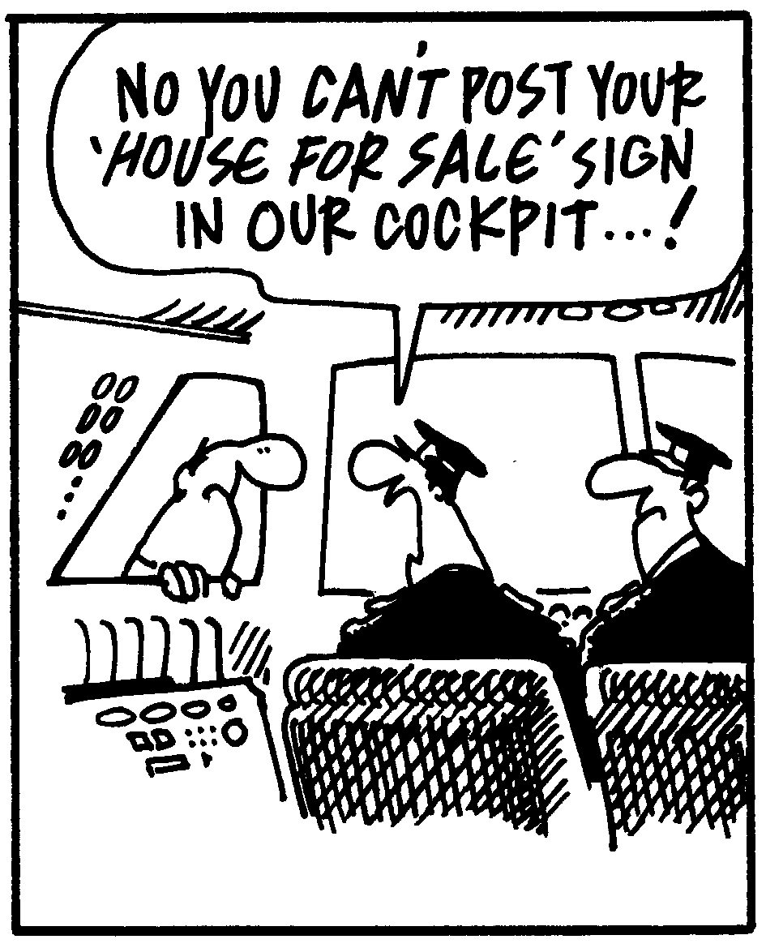



#### Selling St. Charles County News Tyme

### “Insider Tips For Healthy, Wealthy & Happy Living…”

**Joanna Horstmeier**

CDPE, CRS, E-pro, GRI,

### Broker Associate



®

**Saving Money Is Easier Than You Think It Is**

Just about everyone could do with saving a few pennies for a rainy day, but sometimes cutting back on financial expenses can be tough. Here are several easy ways to save money that you may not have considered:

**1. Carpool to work.** Sharing a ride with neighbors or colleagues is not only good for the environment, but it’s easy on the wallet as well. Ride-sharing even one day a week has been shown to save carpoolers 10%–20% of commuting costs. ***Bonus tip:*** If carpooling doesn’t work with your schedule, look into taking public transportation instead of driving. You’ll save money on gas, car maintenance, and parking.

**2. Make a meal plan.** Dining out takes a huge bite out of many family budgets because most people don’t plan ahead. Every weekend, draw up a meal plan for the week ahead and shop for the needed ingredients. The excuse that “there’s nothing to eat” won’t be an option when dinner time rolls around.

***Bonus tip:*** Take a detailed list to the grocery store so you won’t be tempted to buy items on an impulse.

**3. Maintain your vehicle.** Schedule oil changes and appropriate tune-ups when recommended. These have a financial cost upfront, but simple, ongoing maintenance work is far less expensive than major repairs that might be required if these are overlooked.  ***Bonus tip:*** Learn how to change the oil in your car and perform basic maintenance yourself to avoid paying shop fees. Or, find a friend or neighbor who has these skills and make an exchange. An oil change for a week’s worth of dog walking only requires time!

**4. Read e-books.** Instead of buying new hard-copy editions, purchase digital books, which can be significantly less expensive. ***Bonus tip:*** Can’t give up the good ol’ ink-and-paper book? You can still save money by shopping at used bookstores or purchasing used books online. Alternatively, hold a book-swapping party with friends and you’ll all walk away with new-to-you books at no cost.

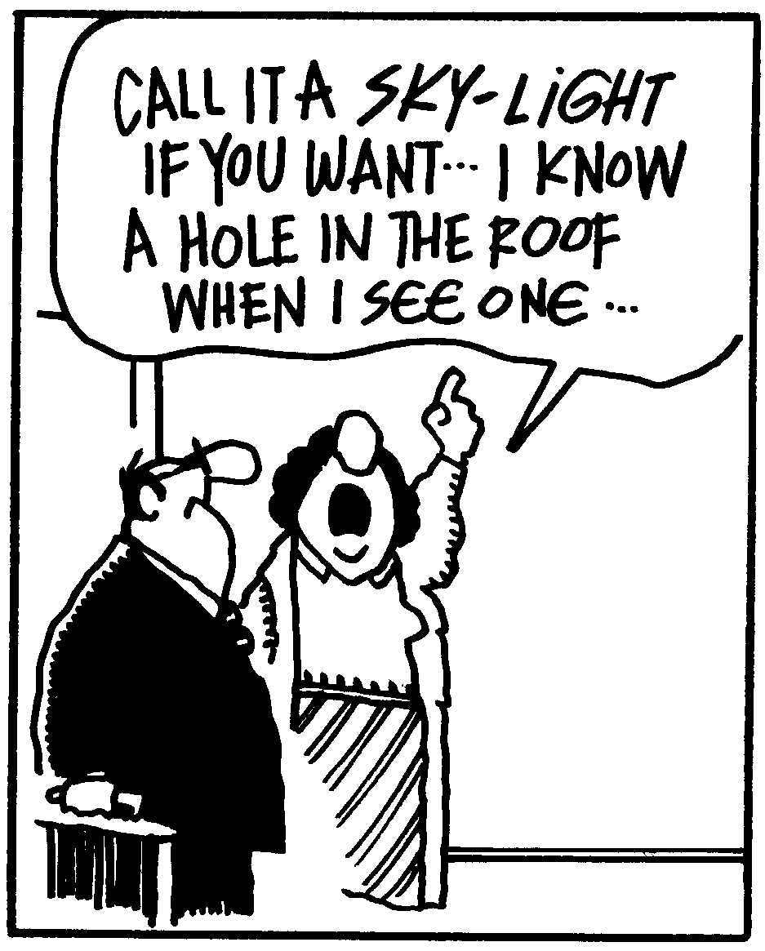

**Warning Before You Sell Your Home...**

Don’t put your home on the market without my Free Consumer Guide titled, “***How To Avoid 7 Costly Mistakes When Selling Your Home***.” My exclusive report will give you all the facts for a fast, top dollar sale. Just call **636-970-0185** anytime, 24 hours, and I’ll rush a copy out to you for free.

**Act Fast In 4 Medical Emergencies**

By their very nature, emergencies happen at the most unexpected times. Knowing what to do in advance of these situations will keep confusion and chaos at bay, and may very well save a life.

**Asthma attack:** Mitigate panic for attack victims by displaying a calming presence. Encourage them to sit down, and loosen their clothing if it’s too tight. Ask if there is a rescue inhaler on hand, and offer to get it if it’s not readily available. Encourage relaxation with slow, deep breathing or meditation. If the attack worsens, help victims get to an emergency room.

**Stroke:** Use the F.A.S.T. test if you believe someone is having a stroke. Check the *face* to see if the mouth is drooping. Ask if they can lift their *arms*. Listen to see if their *speech* is slurred. If you witness these symptoms, call 911 because *time* is of the essence. While waiting for the ambulance, do not offer food, drink, or medicine.

**Choking:** It is important to know that, if someone is coughing, they are still breathing and *not* choking. However, if they cannot speak, cough, or breathe, employ the Heimlich Maneuver. Different versions are detailed at **henryheimlich.com/how-to-perform-the-heimlich-maneuver**. Once the stuck object is dislodged, the choking victim should check in with a physician to assess for bruising or damage to the airway.

**Heart attack:** If someone has chest pain, assume it is a heart attack. Call 911 right away. Check the victim’s airway, breathing, and circulation (ABC). If the person is unconscious, not responsive, and there is no pulse or you are not sure, assume “heart attack” and begin CPR. If you do not know CPR, doctors recommend performing just chest compressions without the rescue breaths. The 911 dispatcher can walk you through the procedure over the phone. You can also take an online CPR course to help you feel prepared, just in case: **www.redcross.org** (search for “Online CPR”).

**Word of the Month…**

Studies have shown your income and wealth are directly related to the size and depth of your vocabulary. Here is this month’s word, so you can impress your friends (and maybe even fatten your wallet!)…

**Social credit** (so-shul kred-it) noun

**Meaning:** A numerical rating that will be given to every Chinese citizen by 2020 based on spending habits, social activities, criminal record, and more. It will be used to help determine things such as employment opportunities and access to housing.

**Sample Sentence:**  Chinese college students need to be mindful of activities that could factor into their social credit.

**Put It On Plastic**Though it’s wise to be thinking about what you pay for by credit card, sometimes it’s a good idea to opt for plastic. For example:

* **Rental cars and hotel rooms:** If you use a debit card, rental car companies and hotels often pull out a large deposit; that’s not the case with credit cards. Also, some credit cards offer insurance for rental cars.
* **Over the phone:** Any time you buy something over the phone or online, use a credit card – just in case your item never arrives.
* **Flights:** Some credit cards have built-in travel protection. This can be handy if buying airline tickets.

**Walk T-Rex, Walk!**

A rare set of Tyrannosaurus rex footprints found in Wyoming has led paleontologists to determine the dinosaur probably walked at about five miles an hour. That’s about the speed of a skilled power walker.

**Quotes To Live By…**

“Fun is good.”

–Dr. Seuss

“The clearest way into the universe is through a forest wilderness.”

–John Muir

“If you want to change the world, go home and love your family.”

–Mother Teresa



**Smart Home Devices 101**

You may have heard of smart home devices, but do you know what they are? Here’s the lowdown on today’s hottest tech trend.

*What is a smart home device?* These are technologically advanced tools that anticipate your needs and desires, promising to make life around the house less stressful. This smart technology allows you to automate your home and monitor it from afar. Need to pre-heat the oven before you leave work? Want to start the coffee pot before rolling out of bed? Done and done.

*How do they work?* Smart products have wi-fi capabilities and are controlled through smartphone apps. With your smartphone in hand, you can control your home’s thermostat, oven, security system, and more.

*What about safety?* Relying on a voice command or a touch of a button to do many things has security risks. To lessen the risk of being hacked, buy from established companies like Amazon or Google. Strengthen your wi-fi security and passwords (ask your internet provider how best to do this).

Brain Teaser…

Using only addition, how can you add eight 8’s and get the number 1,000?

*(See page 4 for the answer.)*

**What’s My Home Worth?**

If you want to know your home’s current value, I will gladly conduct a ***Maximum Value Home Audit***. Request this “no charge” in-depth home value analysis by calling me at: **636-970-0185.**.

**Visa-Free Travel**

Getting a visa to travel can make it a little tougher to cross international borders. Which country has it easiest? According to the 2016 Visa Restrictions Index, these are the countries whose residents have the most travel freedom (visa-free travel):

1. **Germany:** 177 countries and territories
2. **Sweden**: 176 countries and territories
3. **Finland, France, Italy, Spain, and the United Kingdom:** 175 countries and territories
4. **Belgium, Denmark, Netherlands, and the United States:** 174 countries and territories

**What A Player!**

In the 1930s, the U.S. Playing Card Company added a fifth suit to the standard playing card deck – a green eagle. By the end of World War II, it had largely disappeared from the deck.

**Airfare Comparison Websites**

Find the best prices regardless of where and when you want to travel.

**www.google.com/flights** – Find itineraries with the best combo of price, duration of trip, number of stops, and more.

**www.kayak.com/explore** – Search by month or season to figure out where you can get the most bang for your travel buck.

**www.momondo.com** – Offers an airfare calendar graph showing average prices, which is helpful for flexible travelers.

Here’s A Free, Valuable Resource…

Now You Can Search The Home Market, Get Helpful Community Information, AND Receive Important Resources For Saving Time And Money When Buying Or Selling At

<http://sellingstcharles.com>

**FREE Consumer Help Is Just A Phone Call Away**

Learn valuable secrets for saving thousands and avoiding costly mistakes when buying, selling or refinancing a home. Best of all, it’s FREE. Ask about my “**Insider’s Free Resources**” by calling me at: 636-970-0185

**Landscape Maintenance Checklist**

***In the spring:***

* Remove leaves, sticks, and debris that collected throughout winter.
* Prepare garden beds for the season.
* Do a maintenance check on drainage systems and outdoor lighting.

***In the summer:***

* Raise mower height to at least three inches.
* Mulch flower beds as soil dries out.
* Apply fertilizer to lawn mid-summer, if necessary.

***In the fall:***

* Mulch around perennials and plants that need extra insulation.
* Winterize sprinkler system by draining and turn off watering timer.
* Clean up all leaf and plant debris from yard and garden.

***In the winter:***

* Cut grass until temperature drops below 50 degrees F.
* Use winter snow fences or burlap to protect plants from wind and salt.
* Lubricate hand gardening tools to prevent rust.

**Thanks For Thinking of Me!**

Did you know I can help you or any of your friends or family save time and money when buying or selling a home? Thanks for keeping me in mind with your referrals…and spreading the word about my services.

**Brain Teaser Answer:**

888 + 88 + 8 + 8 + 8 = 1,000

**Liar, Liar, Pants On Fire**

A study by the researchers at Brock University in Ontario, Canada, found that parents are bad at telling when their kids are fibbing. Parents were able to discern lying in their kids 10% of the time, while complete strangers could pick out the lies 40% of the time.

**Stain-Free Solutions**

* Remove **tea or coffee** by blotting with a paper towel, dab with distilled white vinegar, and wash as normal.
* Spray hairspray on a **lipstick** stain, and let it sit for 15 minutes. Blot with a clean cloth soaked in warm water. Wash as normal.
* For **blood** stains, soak the item in cold water immediately. Rub regular hand soap on the stain gently, and then rinse in cold water.

**THANK YOU** for reading my

personal newsletter. I wanted to produce a newsletter that has great content and is fun and valuable to you. Your constructive feedback is always welcome.

**AND…**whether you’re thinking of buying, selling or financing real estate, or just want to stop by and say “Hi,” I’d love to hear from you…

**Joanna Horstmeier**

**CDPE - CIPS – CRS – E-pro –GRI**

**And Broker Associate**

**Remax Results - 636-970-0185**

[***Joanna@SellingStCharlesCounty.com***](mailto:Joanna@SellingStCharlesCounty.com)

Disclaimer: The information contained in this letter is intended for informational purposes. It should not substitute as legal, accounting, investment, medical or other professional services advice. Always seek a competent professional for answers to your specific questions. This letter is not intended to solicit real estate properties currently for sale.

**“Who Else Wants To Win**

**A STARBUCKS Gift Card?”**

No winners last month. Let’s see what we can do for April. Who wants to win the Starbucks Gift Card? Last month’s question was:

**Remember “Gone With The Wind”? Who was**

**Scarlett O’Hara’s second husband?**

a) Rhett Butler b) Charles Hamilton c) Frank Kennedy d) Ashley Wilkes

The answer is c) Frank Kennedy. Charles Hamilton was her first husband, and Rhett Butler was her third. So let’s move on to *this* month’s trivia question.

**What U.S. Marine Corps policy, recently released with new regulations, is 32 pages long?**

a) Tattoo b) Marriage c) Personal leave d) Physical fitness

***Call Me At 636-970-0185 OR Email Me At*** [www.SellingStCharlesCounty.com](http://www.SellingStCharlesCounty.com)

***And You Could Be One Of My Next Winners!***

***Real Estate Corner…***

**Q. What do buyers really want when looking for a house?**

**A.** Here are ways to tap into what every buyer wants:

* **Every buyer wants a place to call “home.”** The decision to buy is *emotional,* not 100% logical. Buyers look at a “house,” but they’re really evaluating it for its potential to become their home. Properly staging your house allows buyers to have an emotional experience – seeing their family living there.
* **Every buyer wants a bargain**. Subtly influence buyers by using such phrases as “priced to sell” or “a unique bargain at this price.”
* **Every buyer wants to claim special discounts**.You can motivate a sale by creating a sense of *urgency.* Consider using special terms that expire on a fixed date.

Want to learn more secrets about how to sell your home fast and for the most money? Call and ask for my Free Consumer Report called ***“6 Steps For Selling Your Home For TOP DOLLAR.”***  I’ll send a copy right over to you.

Do you have a question you want answered related to real estate or home ownership? Feel free to call me at 636-970-0185. Perhaps I’ll feature your question in my next issue!