*Call me right now at 636-970-0185 and ask for my Free Consumer Guide to homeowner profits titled, “Make Your Home Show Like A Model Without Breaking The Bank”…*

# 

# July 2017

**St. Charles, MO**



## Inside This Issue…

**Fight Allergies Naturally…Page 1**

**How To Pay Off Student Loans…Page 2**

Don’t Like The Gym? You Can Still Work Out with Technology!…Page 2

Indoor Painting Tips…Page 3

**Answer This Trivia Question and You Could Win River City Rascals Baseball tickets …..Page 4**

**What Factors Should I Consider When Buying Rental Properties?…Page 4**

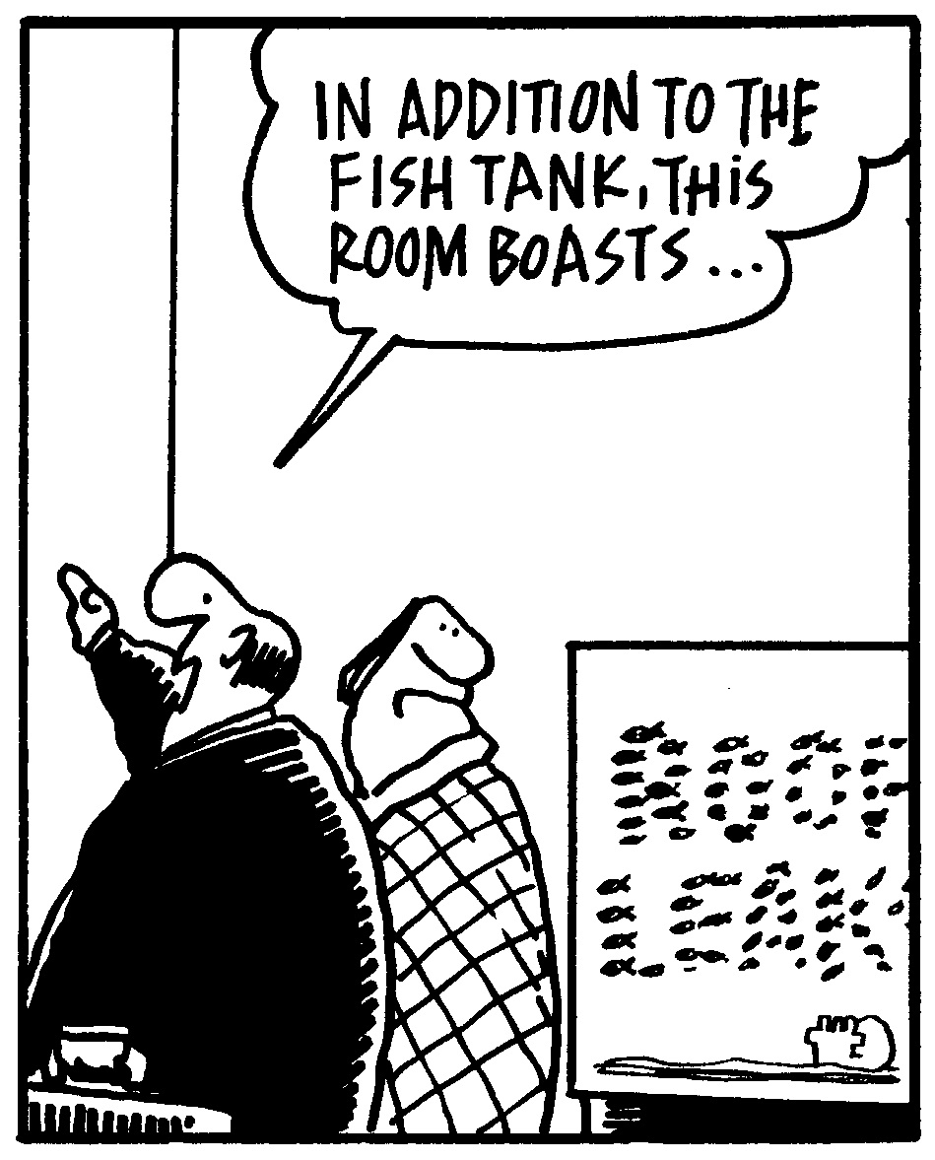

#### Selling St. Charles County News Tyme

### “Insider Tips For Healthy, Wealthy & Happy Living…”

**Joanna Horstmeier**

CDPE, CIPS, CRS, E-pro, GRI,

### Broker Associate





**Using Natural Remedies   
To Cure Allergies**

Does spring fever make you sneeze and the family dog make your eyes water? You’re not alone: The Asthma and Allergy Foundation of America estimates as many as 30% of adults and 40% of children suffer from allergies. To curb the effects, though, consider reaching for one of these natural remedies if your doctor gives his okay.

* **Butterbur** – This root extract is often used to treat coughs, asthma, hay fever, headaches, and stomach ulcers. Though considered safe, the plant itself contains cancer-causing substances, so it’s important to make sure the specific brand you use has had those substances removed.
* **Neti Pot** – Neti Pots are used to prevent and treat upper respiratory conditions, but make sure the water you use is distilled and as sterile as possible. Tap water contains chemicals that might actually make sinus conditions worse.
* **Raw honey** – Eating a tablespoon of local, raw honey every day is supposed to help the body build a tolerance to the regional pollen and allergens in the air.
* **Quercetin** – Naturally found in wine, onions, green tea, and citrus fruit, quercetin is a cell stabilizer, blocking the release of histamine, which causes inflammation. Some sources suggest this is a long-term remedy, and people who suffer from seasonal allergies should take quercetin in the weeks leading up to spring.
* **Steam** – Taking a hot shower or inhaling steam can help clear mucus and keep nasal passages from drying out.

# Save Thousands When Buying A Home…

Did you know there’s a free consumer report revealing ways to save time and money when buying a home? It’s called “***8 Secrets For Saving Thousands When Finding and Buying Your Next Home***,” and it’s great even if you’re not planning to buy soon. Get your free copy by calling me at…**636-970-0185**

**Word of the Month…**

Studies have shown your income and wealth are directly related to the size and depth of your vocabulary. Here is this month’s word, so you can impress your friends (and maybe even fatten your wallet!)…

**Infomania** (in-fo-may-nee-a) noun

**Meaning**: A compulsive desire to check or accumulate news and information, often via a smartphone or computer

**Sample Sentence:** Her infomania drove her to check Facebook every time she had a free moment.

**Quick Tip…**

Stay focused at work and get more done by giving each day a theme – Mondays for organizing, Tuesdays for important phone calls, Wednesdays for management tasks, etc.

**Travel On The Cheap**

Looking for ways to travel the world without breaking the bank? Here are a few ideas:

* Become a house/pet sitter. **TrustedHouseSitters.com** and **MindMyHouse.com** both list hundreds of opportunities.
* Volunteering or making an arrangement of working for lodging can help cut costs. Some volunteer programs have fees associated with them, but check out **WWOOF.net** and **WorkAway.info** for possible options.
* Instead of staying in a hotel, pitch a tent! Check **FreeCampsites.net** for free and cheap places to camp.

**Quotes To Live By…**

“Live in the sunshine, swim the sea, drink the wild air.”

–Ralph Waldo Emerson

“Love is the only force capable of transforming an enemy into a friend.”

–Dr. Martin Luther King, Jr.

“The early bird gets the worm, but the second mouse gets the cheese.”

–Unknown

**Beat Those Student Loans!**

Even if they’re financially savvy, a lot of Americans continue to carry student loan debt with them for years after they’ve graduated from college. Use these strategies to shake off that heavy financial burden:

* **Make it a priority.** Yes, you have a lot of bills to pay, but focus on paying off student loans so you can turn your attention to saving for retirement.
* **Create a repayment plan that works.** Make sure the date your student loan payment is due works with your monthly budget, and consolidate your loans so you only need to make one monthly payment.
* **Focus on variable private loans.** The interest rates on these loans can quickly change, so pay as much toward them as possible while also putting at least a minimum monthly contribution toward fixed-rate federal loans.
* **Sign up for auto-deductions**. If you opt for auto-deductions, you won’t accidentally miss a payment date. Plus, all government and some private lenders charge a slightly lower interest rate if you pay this way.

**Would You Like To Know How Much Your**

**Neighbor’s Home Listed Or Sold For?**

Maybe you’re just curious. Or maybe you want to know how much your home is worth. Either way, I can help…with no “sales pitches” or run-arounds. Call me at 636-970-0185 and I’ll give you all the facts.

**Work Out Without The Gym**

Everyone has their reasons for avoiding the gym, but enough with the excuses! Using technology, today’s gym is wherever you are.

Using smartphone apps, you can find workout programs customized based on gender, interests, and goals. Some are free, such as the **Nike Training Club** app, which comes with more than 100 workouts. Others offer services for a subscription fee (which often costs far less than a monthly gym membership).

If you’re new to working out, don’t feel intimidated. The **Couch to 5K (C25K)** program, for example, helps people new to running get their shoes on and out the door. Many people are incentivized by logging their workouts with others. **Map My Fitness**, for example, lets users set goals, join challenges, and motivate friends.

You don’t have to be a smartphone owner to take advantage of digital workouts. Check YouTube and Vimeo for aerobic, yoga, and weight-lifting workouts you can do without ever leaving home.

B

Brain Teaser…

What do these words have in common: polish, job, herb?

*(See page 4 for the answer.)*

**Real Estate Question?**

Maybe you want to know how much your home is worth. Or maybe you just need a recommendation for a handyman, carpet cleaner or plumber…

Either way, I love hearing from all of my good friends and clients. And I’m happy to help answer questions you might have about anything relating to real estate or home-ownership.

If you have a question, tip or idea, call me at **636-970-0185**. I’m here to help!

**All About The Ocean**

* About 70% of the Earth’s surface is covered by water.
* More people have stepped foot on the moon than have been in the Mariana Trench, the deepest part of the ocean at roughly 7 miles deep.
* About 2/3 of marine life remains unidentified. Recent discoveries include a ghost-like octopod and a “ninja” shark with a glowing head.
* Earth’s largest known waterfall is underwater between Greenland and Iceland.

**Meditation 101**

1. Sit or lie comfortably.
2. Close your eyes.
3. Breath naturally, and focus attention on the breath. Clear your thoughts.
4. Bring attention back to the breath if your mind wanders.
5. Start with two or three minutes, and work up to 10 or 15 minutes.

**Websites to Help ID Plants**

What’s that pretty flower? These sites will help you find out:

* **www.orchidnature.com/orchid-identification/**– A guide to the many types of orchids.
* **www**.**arborday.org/trees/whattree/** – An illustrated, step-by-step process narrows down possible tree types.
* **www.mywildflowers.com/identify.asp** – Identify flowers by color, shape, and bloom month.

**Paint Like A Pro**

Whether you’re inspired to splash a new hue across a room’s walls or they’re just due for a fresh coat of the same ol’ color, make sure you DIY with these tips in mind.

**Choose your paint wisely.** It’s important to choose indoor paint for indoor paint jobs. Water-based paint is easy to use and clean up, while oil-based paint is more appropriate for specialty jobs. Check with an expert at the paint store to choose the right type of paint for your situation.

**Prep like a pro.** This may take more time than the actual painting itself, but take your time here to avoid mistakes. Prep work includes:

* Laying down drop cloths.
* Cleaning off dirty areas.
* Filling in holes in the walls with spackle.
* Sanding any uneven surfaces.
* Priming the walls, if needed.
* Taping off non-paint zones like outlets and molding.

**Do detail work.**  Use a thin brush to paint around window and door frames, baseboards, and trim.

**Use a roller brush.** Roll the full height of the wall and keep a wet edge. Start near a corner, and move over slightly with each stroke of paint. Don’t let the roller become dry, and paint so the open side of the roller frame faces the area that is already painted.

**Let it dry.** Once your entire paint job is dry, make sure everything is evenly coated. Add a second coat as needed. Wait at least 24 hours before removing the tape between the painted walls and unpainted places. Use a sharp utility knife or box cutter to slice the tape; do not just pull it off.

1



**“Who Else Wants To Win**

**River City Rascals Baseball Tickets?”**

Guess who won last month’s Trivia Question? I’m pleased to announce the lucky winner of last month’s quiz was Jennifer Mahon from O’Fallon, MO. Congratulations Jennifer!!!!

**What U.S. Marine Corps policy, recently released with new regulations, is 32 pages long?**

a) Tattoo b) Marriage c) Personal leave d) Physical fitness

The answer is a) Tattoo. So let’s move on to *this* month’s trivia question.

**Which animal in the list below hibernates the longest?**

a) Free-living wood frog b) Black bear c) Lungfish d) Common Poorwill

***Call Me At 636-970-0185 OR Email Me At*** [Joanna@SellingStCharlesCounty.com](mailto:Joanna@SellingStCharlesCounty.com)

***And You Could Be One Of My Next Winners!***

(Prize winners are limited to once per 6 month period.)

**Thanks For Thinking of Me!**

Did you know I can help you or any of your friends or family save time and money when buying or selling a home? Thanks for keeping me in mind with your referrals…and spreading the word about my services.

**Brain Teaser Answer:**

All three words are pronounced differently when the first letter is capitalized.

**Get Out Of Bed …**

… and be ready to face the morning! There are lots of benefits to waking up early. Here’s how to do it successfully.

* Turn off the smartphone at least an hour before bedtime.
* Leave the curtains open and rise with the sun. Use a dawn simulator if you struggle to wake up.
* Wake up at the right time in your sleep cycle. Use an app to help you regulate this.
* Avoid hitting the snooze button.
* Drink a glass of water and exercise first thing in the morning to feel more alert all day.

**THANK YOU** for reading my

personal newsletter. I wanted to produce a newsletter that has great content and is fun and valuable to you. Your constructive feedback is always welcome.

**AND…**whether you’re thinking of buying, selling or financing real estate, or just want to stop by and say “Hi,”  
 I’d love to hear from you…

**Joanna Horstmeier**

**CDPE - CIPS – CRS – E-pro –GRI**

**And Broker Associate**

**Remax Results - 636-970-0185**

[***Joanna@SellingStCharlesCounty.com***](mailto:Joanna@SellingStCharlesCounty.com)

Disclaimer: The information contained in this letter is intended for informational purposes. It should not substitute as legal, accounting, investment, medical or other professional services advice. Always seek a competent professional for answers to your specific questions. This letter is not intended to solicit real estate properties currently for sale.

***Real Estate Corner…***

**Q. How can I build wealth with real estate rental properties?**

**A.** Before purchasing rental property, consider the following factors to make a good investment:

* **Find moderately priced properties**, so you can generate more cash flow than higher priced properties. Your tenant’s rent should cover the mortgage, utilities, and additional expenses in order to produce a cash flow.
* **Get the full cost of owning and repairing the home.** Have a property inspection before you purchase the property to identify any potential repairs. Also, get written quotes from contractors for repairs you’ll need to make before renting out the home.
* **Carefully select your tenants.** Each time a renter leaves, you have to prep it for another tenant by paying for repairs, possible upgrades, and other costs such as advertising, credit and background checks, plus taking time to show the unit. Long-term tenants are better for your investment, so choose wisely and treat them well!

To learn more, call me to request my Free Consumer Report called   
***“How to Avoid 8 Dumb Mistakes Even Smart Investors Make.”***

Do you have a real estate question you want answered? Feel free to call me at 636-970-0185. Perhaps I’ll feature it in my next issue!