*Selling Your Home Soon? You’ll need my Free Consumer Guide titled, “6 Steps For Selling Your Home For TOP DOLLAR.” Call me right now at 636-970-0185 to get a copy…*



# August 2017

**St. Charles, MO**

## 

## Inside This Issue…

**Pros And Cons Of Do-It-Yourself Home Security…Page 1**

**How Food Can Help Prevent Jet Lag…Page 2**

**Rethinking Bottled Water…Page 3**

**New Places To Donate Old Clothes…Page 3**

**Answer This Trivia Question and You Could Win Rascals Baseball Tickets…..Page 4**

**What Makes A Home Attractive To Buyers ?...Page 4**

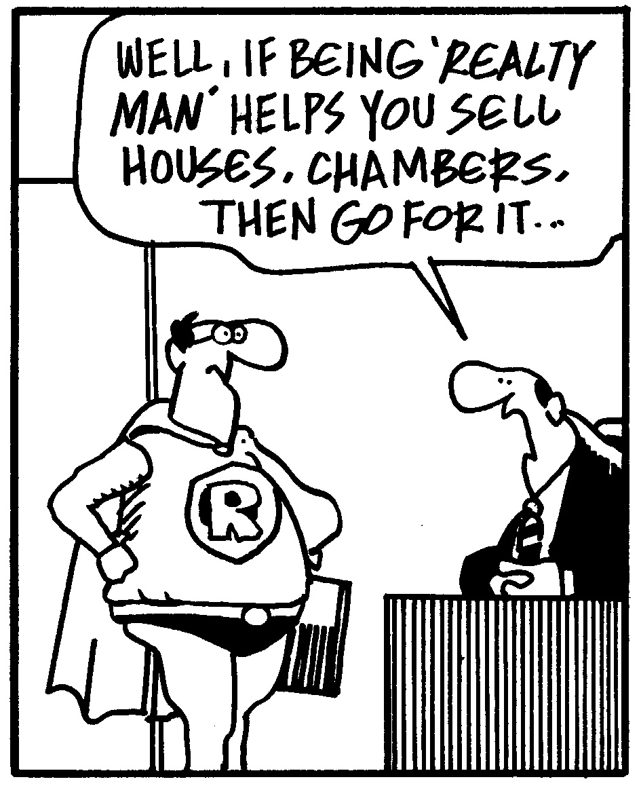



#### Selling St. Charles County News Tyme

### “Insider Tips For Healthy, Wealthy & Happy Living…”

**Joanna Horstmeier**

CDPE, CIPS, CRS, E-pro, GRI,

### Broker Associate





**DIY Home Security – Worth It?**

Having a secure home means you can sleep soundly at night knowing you and your loved ones are completely safe. You can either put the system together yourself or hire a professional to do it. Consider these pros and cons in deciding if installing your own home security is right for you.

***Pros:***

* **Cost.** If you pay for professional installation, expect to pay up to several thousand dollars for services, including arming sensors and motion detectors, and prepping monitoring systems. **Tip:** If you choose professional installation, ask about available promotions to reduce costs.
* **Install the system you want.** You can choose from more customizable systems and services that might result in lower month-to-month monitoring costs.
* **Ownership.** Usually DIY equipment is owned by the person who buys it – you! And, if you move houses, you’re free to take it with you.
* **Step-by-step assistance.** DIY systems usually have prompts, so you can properly follow the installation sequence. Sometimes companies with DIY installation kits also offer on-the-go help by phone.

***Cons:***

* **Time and effort.** You can install at your leisure, but you’ll have to put in the time to make sure it’s done properly. This may include time on the phone trouble-shooting any problems.
* **Lack of expertise.** A professional technician ensures your system is fully and properly installed and can walk you through how to operate it – something you don’t get if you DIY.
* **Fewer warranties.** If you install your own equipment, you may not qualify for warranties because no one can guarantee whether it was done correctly. Additionally, you may invalidate warranties on windows, doors, and other parts of the home when installing the system.
* **Repair costs.** Professional installation often comes with repairs for free or at a reduced cost. With a DIY system, you’re on your own for repairs.



# How To Get Top Dollar Selling Your Home...

If you’re thinking about selling your home soon, request my Free Consumer Guide, “***7 Insider Tips To Net More Money Selling Your Own Home***.” This report will be your secret weapon to maximize the net profits from the sale of your home. You can get a free copy by calling me at….636-970-0185

**Fight Jet Lag With Food**

Jet lag is one of those unfortunate things travelers have to put up with when we’re out on adventures. Or is it?

Studies show that there are eating habits that can help fight the effects of jet lag, including before, during, and after your flight.

* The most important key to avoiding jet lag is **hydration**. Drink plenty of water and avoid dehydrating foods and drinks – such as salty snacks, caffeine, and alcohol.
* A 2016 study published in the Psychology & Health Journal said that long-haul flight attendants who adhered to a **meal schedule** instead of eating whenever they wanted suffered fewer jet lag symptoms. Keep your own eating schedule and skip the snacks.
* Starting out your travel day well-rested is a big help in fighting jet lag. Consuming **carbs the night before a flight** can increase serotonin levels in your brain, and serotonin helps you sleep.
* Focus on **protein when you land** to trigger your brain’s production of norepinephrine and dopamine, which make you more alert. Carry some protein-rich foods with you, which may not be easy to find depending on where you’re going (peanut or almond butter with crackers, protein bars, or hard aged cheese that doesn’t need to be refrigerated).
* Eat foods that naturally contain **melatonin**, a sleep aid, to help your body adjust to new time zones. Cherries are a great source of melatonin (dried cherries work, and are easier to transport than fresh cherries), as is fresh ginger.

**Word of the Month…**

Studies have shown your income and wealth are directly related to the size and depth of your vocabulary. Here is this month’s word, so you can impress your friends (and maybe even fatten your wallet!)…

**Textspeak** (tex-speek) noun

**Meaning:** Common language used when writing text messages, which consists of abbreviations, acronyms, initials, and emoticons.

**Sample Sentence:**  Her teenage daughter’s text message was entirely in textspeak: R U 4 Real? LOL!

**It’s A Fact**

* Woody Allen spends $100 a week on lottery tickets.
* Mail is delivered to the bottom of the Grand Canyon by mule.
* New Yorkers would be willing to pay approximately $56/month on average to shave a minute off their commute.
* Fredric Bauer invented the Pringles can – and when he died, his ashes were buried in one.

**One-minute Immunity Boost**

Researchers have found that taking a cold shower that lasts about one minute (if you can stand it!) actually helps to boost your immunity. Your body will try to warm itself quickly, and the immune system is kicked into high gear. No word about how your heart will handle it, though…

**Have A Laugh…**

So, my wife told me I had to quit acting like a flamingo. I had to put my foot down.

**Quotes To Live By…**

“It takes nothing to join the crowd. It takes everything to stand alone.”

–Hans F. Hansen

“I believe more in the scissors than I do in the pencil.”

–Truman Capote

“If you always do what interests you, at least one person is pleased.”

–Katharine Hepburn



**Alternatives to Bottled Water**

You’ve likely heard that bottled water has major environmental consequences, but how bad is the problem? Here are a few facts from **thewaterproject.org** that illustrate the severity of the situation:

* Approximately 80% of single-use water bottles in the U.S. become “litter,” and one bottle takes more than 1,000 years to bio-degrade.
* U.S. landfills have two million tons of discarded water bottles in them.
* It takes three liters of water to package one liter of bottled water.

In response to the bottled water problem, some cities and businesses have banned it, but what can you do?

* Skip the single-use water bottle, and invest in a reusable water bottle. If you forget it, buy multiples to keep in vehicles, the office, and your gym bag.
* Drink tap water. Several studies have been done to show municipal tap water is usually just as safe as bottled water.
* Refrigerate water. Cooling tap water helps remove the chlorine taste many people feel is in tap water.
* Boil water if you are concerned water might be contaminated.

Brain Teaser…

What are the next three numbers in this series? 4, 6, 12, 18, 30, 42, 60, 72, 102, 108, ?, ?, ?

*(See page 4 for the answer.)*

**What’s My Home Worth?**

If you want to know your home’s current value, I will gladly conduct a ***Maximum Value Home Audit***. Request this “no charge” in-depth home value analysis by calling me at:

636-970-0185.

**Efficient House Cleaning**

Get yourself in the right mindset and clean your home more efficiently.

1. Schedule cleaning as a job.
2. Wear comfortable, washable clothing. Have aprons, goggles, and cleaning gloves handy, if needed.
3. Invest in well-made cleaning tools.
4. Pick up clutter before cleaning.

**All Across America**

How long would it take to cross the USA – and how much would it cost – in different forms of transportation?

*Hot Air Balloon*: 17 days – $215,789

*Private Jet*: 6 hours – $38,000

*Uber*: 4 days – $6,400

*Amtrak Train*: 2 days, 13 hours – $455

*Horse & Carriage*: 46 days – $89,515

*Bus*: 2 days, 17 hours – $150

**What Is Awe?**

Experiencing a sense of awe occurs when people encounter things that are large and vast – such as walking among tall trees – transcending their current understanding of the world. These experiences have been shown to lead people to be more altruistic, less entitled, humbler, and more aware of others.

**Book And Reading Websites**

Love to read? Bookmark these sites!

**www.goodreads.com** – Track books you’ve read or want to read.

**www.** **bookbub.com** – Alerts on book sales based on selected criteria.

**www.bookriot.com** – Reviews, book-related articles, and relevant podcasts.

Here’s A Free, Valuable Resource…

Now You Can Search The Home Market, Get Helpful Community Information, AND Receive Important Resources For Saving Time And Money When Buying Or Selling At **www.SellingStCharles.com**

**Donating Clothes And Accessories**

Is it time for a wardrobe facelift? Before hauling your old clothes away to the same secondhand store or tossing them in the trash, consider these options.

**Blue jeans:** Old blue jeans donated through **bluejeansgogreen.org** will be turned into insulation in communities that need it most.

**Shoes:** Both **soles4souls.org** and **oneworldrunning.com** accept gently worn shoes to donate to people in need around the world.

**Wedding and formal dresses:** Most people only wear formal clothing a few times, so if your wedding dress or formal gowns are still in great condition, pass them on! Soon-to-be-military brides are on the receiving end at **bridesacrossamerica.com**, and Project G.L.A.M. (**wgirls.org**) provides teenage girls with prom dresses.

**Eyeglasses:** If you’ve updated your prescription lately, donate old frames and lenses to **new-eyes.org**, where they’ll be passed on to someone who can’t afford new eyeglasses.

**Thanks For Thinking of Me!**

Did you know I can help you or any of your friends or family save time and money when buying or selling a home? Thanks for keeping me in mind with your referrals…and spreading the word about my services.

**Brain Teaser Answer:**

The next three numbers are 138, 150, and 180. Each number in the list is flanked by two prime numbers. In this case, 138 (137 and 139 are prime), 150 (149 and 151 are prime), and 180 (179 and 181 are prime).

**Get Your Run On**

Between 2009 and 2014, the number of people worldwide running marathons increased by 13.25%. Asia, in particular, saw a 92.4% increase in marathon running in that time period.

**Cut Down On Airline Fees**

Don’t be nickel-and-dimed on your next flight. Save money with these moves:

* Nearly every airline has baggage fees for checked luggage (tripadvisor.com/AirlineFees), so pack light and carry on or use a co-branded credit card to waive fees.
* Don’t choose a seat prior to flying if the airline charges seat fees.
* Use your smartphone as your boarding pass to avoid printing fees, which discount airlines may impose.

**THANK YOU** for reading my personal newsletter. I wanted to produce a newsletter that has great content and is fun and valuable to you. Your constructive feedback is always welcome.

**AND…**whether you’re thinking of buying, selling or financing real estate, or just want to stop by and say “Hi,” I’d love to hear from you…

**Joanna Horstmeier**

**CDPE - CIPS – CRS – E-pro –GRI**

**And Broker Associate**

**Remax Results - 636-970-0185**

[***Joanna@SellingStCharlesCounty.com***](mailto:Joanna@SellingStCharlesCounty.com)

Disclaimer: The information contained in this letter is intended for informational purposes. It should not substitute as legal, accounting, investment, medical or other professional services advice. Always seek a competent professional for answers to your specific questions. This letter is not intended to solicit real estate properties currently for sale.

**“Who Else Wants To Win**

**Rascals Baseball Tickets?”**

We must have had a tough question last month. No winners. Let’s see what we can do this month. What is your answer? You can be the winner!!!!

**Which animal hibernates longest in the list below?**

**a) Free-living wood frog b) Black bear c) Lungfish d) Common Poorwill**

The answer is a) Free-living wood frog. The free-living wood frog can remain completely frozen for up to seven months a year. So let’s move on to *this* month’s trivia question.

**The founder of this frozen food company got the idea for his brand from watching Inuit people ice fish in the 1900s.**

a) Green Giant b) Igloo c) Pepperidge Farms d) Birds Eye

***Call Me At 636-970-0185 OR Email Me At Joanna@SellingStCharlesCounty.com***

***And You Could Be One Of My Next Winners!***

***Real Estate Corner…***

**Q. How can I make my home attractive to buyers?**

**A.**  When selling your home, look at your home through a potential buyer’s eyes, and follow these steps to make it show well and receive a good offer:

* **Clean and repair.** Your buyer’s first impression is from the street. Clean up the yard, the landscaping and check your exterior paint job. On the inside, shampoo the carpets, scrub the floors and clear off all the counters. Remove old wallpaper and paint the walls a neutral color. Fix things that need fixing, like squeaky doors, broken tiles etc.
* **De-Clutter.** Get rid of all that “stuff” you’ve accumulated in the garage, the backyard and the basement. And don’t forget the closets!
* **“Stage” it to look like a model home.**  Put away your personal items and remove large pieces of furniture. Ask your REALTOR® for ways to “dress up” your home (candles, new linens etc.) to maximize your selling potential.

For more tips, ask for my Free Consumer Report called ***“Make Your Home Show Like A Model Without Breaking the Bank.”*** I’ll get a copy to you.

Do you have a real estate question you want answered? Feel free to call me at 636-970-0185. Perhaps I’ll feature it in my next issue!