*Buying A Home Soon? Get my Free Consumer Guide, “8 Secrets For Saving Thousands When Buying Your Home.” Call me right now at 636-970-0185 for details…*

# 

# September 2017

**St. Charles**



## Inside This Issue…

**Stay Safe on the Road with Defensive Driving Skills…Page 1**

**Secrets to Know When Booking a Cruise…Page 2**

Learn How to Say No, Nicely…Page 2

Tips to Make the Most of Your Outdoor Living Space…Page 3

**Answer This Trivia Question and You Could Win a Starbucks Gift Card...Page 4**

**What Advice Do You Have For First-Time Homebuyers?…Page 4**

#### Selling St. Charles County News Tyme

### “Insider Tips For Healthy, Wealthy & Happy Living…”

**Joanna Horstmeier**

CDPE, CIPS, CRS, E-pro, GRI,

### Broker Associate







**Road Safety: Defensive Driving**

Being a safe driver is about more than just obeying the speed limit. There are skills known as “defensive driving tactics” that can help keep you out of trouble on the road. Here are a few defensive driving techniques anyone can do:

* **Pay Attention to Your Surroundings** – You might think you already do this, but driving is something most of us do by motor memory (especially on a boring commute). It’s easy to get distracted by a song on the radio or a bird flying by. Stay alert and you’ll be more prepared if something appears in front of you on the road. This also means putting down the phone. If you need to take a call or send a text, pull over (please!).
* **The 2-Second Rule** – In order to maintain a safe following distance behind the car in front of you, choose a roadside landmark (like a tree or a road sign). When the car in front of you passes it, start counting “one Mississippi, two Mississippi.” It should take you two seconds or more to reach the same landmark. If you get there sooner, you’re following too closely.
* **Avoid Blind Spots** – You probably know where the blind spots are in your own car, and you’re accustomed to compensating when you need to back up or change lanes. You can’t count on everyone else to do the same in their own cars, however, so to be on the safe side you should avoid driving in another car’s blind spots. If you can’t see the other car’s side mirrors, assume that they can’t see you.
* **Expect the Unexpected** – Even when you have a green light, make sure there isn’t someone running a red coming the other way. Even if the car in front of you doesn’t have a blinker on, be prepared in case they make a sudden lane change. Even if you assume the car behind you will slow down as traffic is building, keep an eye on your rearview mirror just in case.

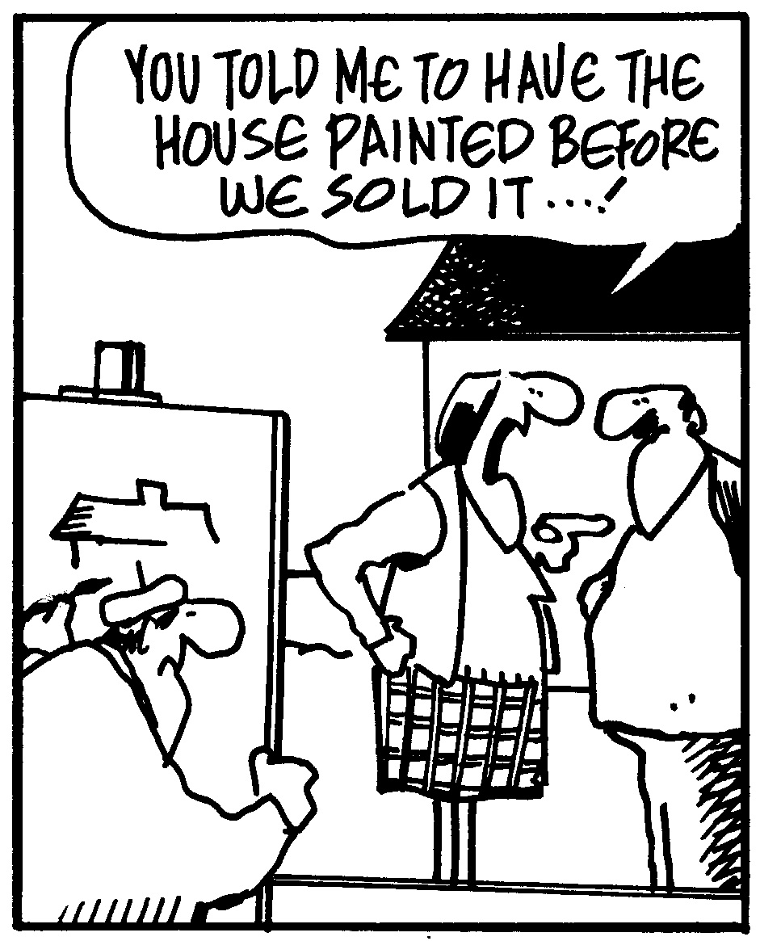

# Learn How To Maximize The Value Of Your Home

Did you know there’s a free consumer report showing what to fix to net the most value for your home? It’s called “***Make Your Home Show Like A Model Without Breaking The Bank***” and it’s an essential guide to homeowner profits. You can get a free copy by calling me at…**636-970-0185**

**4 Tips When Booking a Cruise**

Planning a cruise trip involves more research than you might think. Here are some important things to know before you book your cruise.

1. **Pick the Right Cruise Line** – Know which cruise lines have a party atmosphere, and which are more geared to peace and quiet. (Depending on your preference!) Try a site like **www.cruisecritic.com** to help you decide.
2. **Read the Fine Print** – It might be boring, but the fine print could have information about what’s non-refundable, what’s included in the beverage package, if your cabin is chosen for you, and more.
3. **Choose the Right Cabin** – An interior cabin might make you feel claustrophobic. A cabin next to a nightclub, an elevator shaft, or the anchor means noise at potentially odd hours. A cabin near the front or back of the ship, or higher up on the ship, are where seasickness is most likely.
4. **Look at a Detailed Itinerary** – Know how long you’ve got in each port, and how long it takes to get from the port to the areas you want to visit. Just because it indicates that you have “one day” in port doesn’t mean you’ve got 12 hours to explore.

**Word of the Month…**

Studies have shown your income and wealth are directly related to the size and depth of your vocabulary. Here is this month’s word, so you can impress your friends (and maybe even fatten your wallet!)…

**Fanfaronade** (fan-fer-uh-neyd) noun

**Meaning:** Bragging, bravado, bluster

**Sample Sentence:** “…sometimes you baffle me by the fanfaronade behind your foolish words.”

–Raphael Sabatini, *The Black Swan*

**Plant the Right Wildflowers**

Planting wildflowers beautifies your property *and* helps bees. But make sure the seeds you plant are local and not invasive flower species! Check with a garden center or nursery to get the right seeds for your environment.

**The Original Baby Ruth**

Did you know that the Baby Ruth candy bar was named for President Grover Cleveland’s daughter, Ruth?

**Many Uses for Lemons**

Lemons might be the most useful – and inexpensive – ingredient you have at home! Here are just a few of the ways to use lemons that you might not know.

* Get rid of garbage disposal odors by adding a couple of lemon chunks.
* Polish stainless steel or banish ants with lemon juice.
* Drink a little lemon juice to bump up your metabolism or relieve throat pain.
* Keep apples and guacamole from turning brown with lemon juice.
* Remove stains on fingernails by sticking your fingers in a lemon for a few minutes.

**Quotes To Live By…**

Education is the most powerful weapon which you can use to change the world.

–Nelson Mandela

Try to be a rainbow in someone’s cloud.

–Maya Angelou

Start every day off with a smile and get it over with.

–W.C. Fields

**FREE Consumer Help Is Just A Phone Call Away**

Learn valuable secrets for saving thousands and avoiding costly mistakes when buying, selling or refinancing a home. Best of all, it’s FREE. Ask about my “**Insider’s Free Resources**” by calling me at: 636-970-0185

**DID YOU KNOW**…

Unlike most real estate agents, I *DON’T* spend my time pestering people with phone calls or bothersome interruptions to find good clients. Instead, I dedicate 110% of my time and energies to providing such outstanding service, people naturally think of me when a friend or family member needs help buying or selling a home. THANKS for your referrals!

**How to Say No (Nicely)**

Saying “no” to friends, family, and coworkers often means you get to say “yes” to your own needs. Doing so politely means people still like you! Here are ways to say no that won’t alienate others:

* **When your boss gives you a new assignment:** “That project sounds interesting. I already have a lot on my plate, what should I put on the back burner to accommodate this?”
* **When you’re asked to give to a charity:** “I’ve already donated my planned amount this month (or year), but tell me more about this charity for my next charitable round of giving.”
* **When you’re asked to lend your truck for a move:** “I’m sorry, I don’t loan out my vehicle, but let’s talk about the date – maybe I can do the driving myself.”
* **When you’re asked to run the school bake sale – again:** “You know, I think I’ve done the last two. Why don’t we see if someone else can take a turn?”

B

Brain Teaser…

A man pushes his car to a hotel and tells its owner that he is bankrupt. Why?

*(See page 4 for the answer.)*

**Real Estate Question?**

Maybe you want to know how much your home is worth. Or maybe you just need a recommendation for a handyman, carpet cleaner or plumber…

Either way, I love hearing from all of my good friends and clients. And I’m happy to help answer questions you might have about anything relating to real estate or home-ownership.

If you have a question, tip or idea, call me at **636-970-0185** I’m here to help!

**Storing Sheet Sets Smartly**

Fold all the sheets in a set except for one pillowcase. Then, tuck all the folded sheets and the other pillowcases inside the remaining pillowcase. This keeps your linen closet organized and means you don’t need to hunt for all the pieces of a set to make the bed!

**Websites for Travel Deals**

Travel isn’t cheap, but it doesn’t have to cost a fortune, either. Here are some websites that will help you save:

**www.airfarewatchdog.com** – Plug in your home airport to get regular email updates of the latest deals on flights from where you live. AirfareWatchdog makes hunting for a cheap flight easy, especially if you’re not picky about where you’re going.

**www.cruisecompete.com** – Let travel agencies compete to offer you the best deals on cruises, no matter when or where you want to travel. Sign up for a CruiseCompete account and let the deals come to you.

**www.whichbudget.com** – There are small, budget airlines all over the world, but we usually don’t know their names unless we know a country well. With WhichBudget, you can search for cheaper flights on the budget airlines that serve nearly any international destination you’re visiting.

**Comfortable Outdoor Living**

Making the most of your outdoor living space gives you more space for relaxing and entertaining. Here are some ideas to create your own welcoming areas for outdoor living.

* **Add visual interest to an outdoor space** with brightly-painted planters or colorful throw pillows. They’re easy to update when your favorite color changes, and small enough to add more whenever you like.
* **Dual-purpose furniture is useful in a small outdoor space**. For instance, bench seating that’s also storage and a table that has a planter underneath reduce the furniture footprint without sacrificing utility.
* **Walkways invite exploration into a larger yard**, and keep guests from accidentally stepping on seedlings. Curving walkways through trees or bushes can also create more intimate spaces for entertaining without overcrowding in one spot.
* **Your indoor fireplace is probably a focal point, so why not give your backyard a similar treatment**? Digging a fire pit into your lawn is an inexpensive option. If you don’t want to give up that space in your yard permanently, there are also movable fire pit units you can buy, allowing you to store them when they’re not in use.
* **Creative outdoor lighting** not only provides a warm glow, it also means you can use your outdoor space into the night. Simple DIY solutions include strings of outdoor globe string lights around the porch, small white fairy lights wrapped around tree trunks, or candles in Mason jars twinkling on tables. For an even bigger “wow” factor, wire a chandelier over an outdoor dining table.
* **Combine outdoor lighting and pest control in one.** Fill mason jars with fresh rosemary sprigs, slices of limes or lemons, and about 10 drops of lavender essential oil. Add water and a floating candle to the top. Mosquitos don’t like the smell, but you will.

1



**Thanks For Thinking of Me!**

Did you know I can help you or any of your friends or family save time and money when buying or selling a home? Thanks for keeping me in mind with your referrals…and spreading the word about my services.

**Brain Teaser Answer:**

He is playing Monopoly.

**DIY Produce Wash**

Make your own solution to clean fruits and veggies before you eat them – even if you’re buying organic produce.

* Mix 2 cups of water with ½ cup white distilled vinegar and the juice of 1 lemon, and *voila*! You’ve got an easy and inexpensive way to make sure your produce is clean.
* Vinegar combined with lemon juice kills bacteria and washes away any remaining pesticides and dirt.
* Make sure you store the mixture in the fridge, to keep the lemon juice fresh.

**True Tails**

If you lift a kangaroo’s tail off the ground, it can’t hop away. That’s if you’re brave enough to sneak up behind one…

**THANK YOU** for reading my

personal newsletter. I wanted to produce a newsletter that has great content and is fun and valuable to you. Your constructive feedback is always welcome.

**AND…**whether you’re thinking of buying, selling or financing real estate, or just want to stop by and say “Hi,”  
 I’d love to hear from you…

**Joanna Horstmeier**

**CDPE - CIPS – CRS – E-pro –GRI**

**And Broker Associate**

**Remax Results - 636-970-0185**

[***Joanna@SellingStCharlesCounty.com***](mailto:Joanna@SellingStCharlesCounty.com)

Disclaimer: The information contained in this letter is intended for informational purposes. It should not substitute as legal, accounting, investment, medical or other professional services advice. Always seek a competent professional for answers to your specific questions. This letter is not intended to solicit real estate properties currently for sale.

**“Who Else Wants To Win**

**A Free Starbucks Gift Card?”**

I am so pleased to announce that the winner for our Trivia Contest last month was

Steve Swyers! Congratulations Steve from St. Peters!!

Who will be our next winner?

**The founder of this frozen food company got the idea for his brand from watching Inuit people ice fish in the 1900s.**

a) Green Giant   b) Igloo c) Pepperidge Farms  d) Birds Eye

The answer is d) Birds Eye. Clarence Birdseye learned to quick-freeze his daily catch from Inuit fishermen. So let’s move on to *this* month’s trivia question.

**Remember Roy Rogers and Dale Evans? Roy's horse was named Trigger. What was Dale's horse's name?**

a) Daisy b) Scout c) Buttermilk d) Tulip

***Call Me At 636-970-0185 OR Email Me At*** [Joanna@SellingStCharlesCounty.com](mailto:Joanna@SellingStCharlesCounty.com)

***And You Could Be One Of My Next Winners!***

***Real Estate Corner…***

**Q. What advice can you give to first-time homebuyers?**

**A.**  The best advice is to learn from the mistakes of others.Here are three common examples:

* **Not knowing what you can afford**. Examine your budget, get a copy of your credit report, and sit down with a qualified lender to determine how much of a loan you can afford. Feel free to ask me for a list of lender recommendations, then make sure you comparison shop for a mortgage.
* **Forgetting to consider the overall costs of home ownership.** You can make the monthly payment, but remember to add in the cost for homeowners’ insurance, property taxes, utility costs, plus maintenance.
* **Paying too much for a beautifully staged home.** The home looks *perfect*, but will it look that way when you move in *your* furniture?

If you’re buying a home for the first time, you should have a copy of my Free Consumer Report called, ***“Top 10 First-Time Homebuyer Mistakes To Avoid.”*** Call me and I’ll send a copy out to you.

Do you have a real estate question you want answered? Feel free to call me at 636-970-0185. Perhaps I’ll feature it in my next issue!