*If you’re thinking about selling your home soon, request my Free Consumer Guide, “7 Insider Tips To Net More Money Selling Your Own Home.” Call me right now at 636-970-0185 for details…*

# 

# November 2018

**St. Charles, MO**



## Inside This Issue…

**Should You Use A Credit Union Or Bank?…Page 1**

**Night Owl Vs. Early Bird…Page 2**

Keep Rodents Out Of Your Car…Page 2

Bedroom Organization: A Checklist…Page 3

**Answer This Trivia Question and You Could Win a FREE Car Wash...Page 4**

**Will I Net More Money If I Sell My Home Myself or Should I Hire a REALTOR® to Do It?…Page 4**

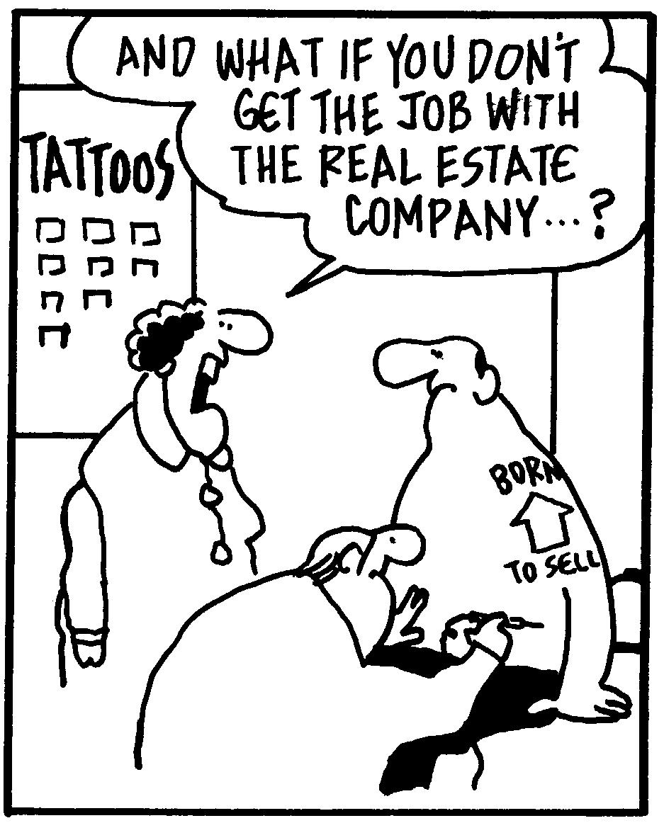

#### Selling St. Charles County News Thyme

### “Insider Tips For Healthy, Wealthy & Happy Living…”

**Joanna Horstmeier**

CDPE, CIPS, CRS, E-pro, GRI,

Broker Associate

### 





**Credit Union Or Bank:**

**Which Is Best For You?**

There are essentially two options when it comes to storing your money: credit unions and banks. Credit unions are non-profit organizations that exist to serve a certain community whereas banks are for-profit enterprises that are generally more physically accessible. Both have pros and cons, and it’s important to consider your specific situation when deciding which to use.

**Customer service:** Credit unions are owned by their members, and personal engagement is emphasized. As non-profit organizations, credit unions tend to be more focused on their community members versus banks. However, banks may be more likely to have 24/7/365 phone support.

**Convenience:** The localized nature of credit unions means there are fewer branches. However, a CO-OP network among credit unions offers almost 30,000 surcharge-free ATMs across the United States, but your credit union needs to be a part of this network in order to take advantage of it. In general, national banks have a wide network of branches and ATMs, though regional banks may not have as many branches.

**Eligibility:** Just about anyone can walk into a bank and open an account. Not so with credit unions, which cater to specific demographics or affiliations such as certain geographic areas, employee groups, or social groups. However, banks also typically have higher minimum balance requirements, making them less accessible for some people.

**Financial and other benefits:** Credit unions often pass on the savings from their non-profit status to customers. This means customers generally get higher rates on savings accounts and lower rates on loans and credit cards. However, banks tend to have credit card affiliations with sign-up bonuses and rewards programs for responsible card holders.

**Thinking Of Selling Your Home Soon?**

Don’t attempt to sell your home without my Free Consumer Guide, “***6 Steps For Selling Your Home For Top Dollar****.”* My exclusive report will give you all the facts for a fast, top dollar sale. Just call **636-970-0185** anytime, 24 hours, and I’ll rush a copy out to you for free.

**Healthy Living, Day Or Night**

The early bird gets the worm, but the night owl can also be happy and healthy. Whether you rise before the sun or drop into bed long after the sun sets, make the most of your waking hours.

*If you are a morning person:*

* **Set a regular bedtime.** Going to bed at the same time every night ensures you’ve received enough rest when the alarm goes off.
* **Maximize the morning.** Write in a journal, go to the gym, do a few chores, and give yourself some creative time before anyone else wakes up.
* **Avoid alcohol and caffeine at night.** To feel fully refreshed early in the morning, sip caffeine-free herbal tea instead.
* **Make a to-do list before bed.** Don’t let tomorrow’s tasks rattle around in your head all night long.

*If you are a night person:*

* **Do chores in the evening.** Pre-prep breakfast, pack lunches for the kids, take a shower, and lay out your clothes for the next day.
* **Ask for flex time at work.** This allows you to do your best work later in the day.
* **Don’t oversleep.** Set a regular wake-up time and stick to it.
* **Get sunshine early in the day.** Welcome in the natural light to maximize your daytime hours. Minimize electronic usage and artificial light at night.

**Word of the Month…**

Studies have shown your income and wealth are directly related to the size and depth of your vocabulary. Here is this month’s word, so you can impress your friends (and maybe even fatten your wallet!)…

**Blogosphere** (blog-o-sfeer) noun

**Meaning**: A slang term for all of the blogs on the internet, collectively

**Sample Sentence:** Starting a blog about cats connected me to the large community of cat-bloggers in the blogosphere.

**Digital Estate Planning**

With today’s digital footprint, it’s not enough to make plans for your material possessions when estate planning. Make things easier for loved ones by preparing your digital assets as well.

* Write down usernames and passwords, seal them in an envelope, and secure them in a safe so they are opened only upon death.
* Create family sharing accounts on movie- and music-sharing services.
* Enlist a power of attorney to make accessing accounts easier.

**Book-Length Palindromes**

Palindromes are sentences or words read the same forward and backward, like “mom” or “racecar.”Some authors have even written entire books this way!

Two novels written in palindrome are *Satire: Veritas* by David Stephens (58,795 words) and *Dr Awkward & Olson in Oslo* by Lawrence Levine (31,954 words).

**Quotes To Live By…**

“Be less curious about people and more curious about ideas.”

–Marie Curie

“Siblings are the people who teach us about fairness, cooperation, and kindness, quite often the hard way.”

–Pamela Dugdale

“I always knew I was a star, and now the rest of the world seems to agree with me.”

–Freddie Mercury

Here’s A Free, Valuable Resource…

Now You Can Search The Home Market, Get Helpful Community Information, AND Receive Important Resources For Saving Time And Money When Buying Or Selling At **www.SellingStCharlesCounty.com**

**Rodent-Free Vehicles**

Forget snakes on a plane … you’re more likely to find mice in your car! Even if you park in a garage, pesky rodents can chew up wiring, cause fluid leaks, and cause serious damage to vehicles. Here’s how to keep them out.

* Avoid parking in places where rodents live such as wooded areas and tall grass.
* When parked in a garage, open the car’s hood. This gets rid of the warm, dark area rodents are attracted to. Also, place a bucket of mothballs beneath the vehicle.
* Don’t keep food in your vehicle.
* Set mouse traps in the vehicle to catch any critters that get inside. Look into using other rodent deterrents in the vehicle as well, including trying peppermint oil and cedar wood.
* Sprinkle fox urine powder around the outside perimeter of the car. You can find this product at most home improvement stores.

B

**Keep Your Bedroom Organized**

You spend almost one-third of your life in the bedroom. This should be a place of rest and relaxation, so it’s worth investing time to make it as stress-free and easy to navigate as possible. **(Watch for next month’s checklist: your bathroom!)**

* **Hang artwork on the walls.** Avoid cluttering up dressers and nightstands with clunky items. Instead choose decorative pieces that can be hung.
* **Use storage space under the bed wisely.** Buy clear, flat plastic bins and strategically tuck away out-of-season clothing and shoes you don’t wear on a regular basis. Depending on a bed’s height, you might also be able to hide luggage.
* **Invest in proper linen storage.** If the bed is exploding with pillows and blankets, invest in a blanket rack and baskets so these extra items have a storage space other than the floor.
* **Maintain a minimal nightstand.** The only things on your nightstand should be what you use every night before going to sleep and anything you use as soon as you wake up. Everything else should be stored somewhere more appropriate. Using a nightstand with drawers can help alleviate the clutter problem.
* **Buy a hamper.** Put it near the closet to keep clothes contained to one area of the room.
* **Contain garbage.** A small, attractive trash bin in a convenient location keeps dirty tissues and paper scraps off of nightstands and dressers.
* **Wrangle your closet.** Your closet is not the same thing as your bedroom, so it shouldn’t spill out into the room. Do a full-closet organization sweep at least once a season, but maintain daily order by:
  + Keeping a donation bin or bag in your closet so you can drop things in as needed.
  + Spending 10-15 minutes once a week rehanging and refolding clothes that have fallen out of place.
  + Utilizing the closet door to hang belts, hats, scarves, and jewelry at eye level. Try a special door rack made for this purpose.

Brain Teaser…

What do these words have in common: polish, job, herb?

*(See page 4 for the answer.)*

**Real Estate Question?**

Maybe you want to know how much your home is worth. Or maybe you just need a recommendation for a handyman, carpet cleaner or plumber…

Either way, I love hearing from all of my good friends and clients. And I’m happy to help answer questions you might have about anything relating to real estate or home-ownership.

If you have a question, tip or idea, call me at **636-970-0185**. I’m here to help!

**Maintain Kids’ Messes**

Buy a big, cheap, dishwasher-safe serving tray and use it to help corral your kids’ potentially messy art projects. Let kids unleash their inner artists with finger paints, Play-Doh, and other art supplies, then clean everything up with an easy wash or wet towel.

**Packing Hacks**

Make the most of your suitcase space!

* Stuff underwear and socks in shoes.
* Roll clothes like t-shirts instead of folding them.
* For items that don’t roll easily, fold and file them from front to back instead of stacking.
* Use packing cubes to organize by size, style, or type of clothing.
* Use compression bags for bulky items and dirty laundry.
* Manage and maintain small items with clear, zip-top baggies.

**Bookmarking Websites**

Use these sites to save online content that you want to revisit later.

**www.getpocket.com** – Save written content to read offline.

**www.instapaper.com** – A newspaper-like reading experience.

**www.flipboard.com** – A visually oriented reading experience grouped by topic.

1



**“Who Else Wants To Win**

**A free Car Wash?”**

Last month must have been a tough question……no winners!

Let’s see if we can get one this month!!!

**One of the largest diamonds ever found in North America was found  
in what U.S. state, which also names diamonds as its official state gem?**

a) Georgia  b) Iowa c) Alabama d) Arkansas

The answer is d) Arkansas. The Uncle Sam diamond, found in 1924, weighed 40.23 carats. So let’s move on to *this* month’s trivia question.

**The name for PEZ candy was derived from a word in what language?**

a) French b) Portuguese c) German d) Japanese

***Call Me At 636-970-0185 OR Email Me At Joanna@SellingStCharlesCounty.com***

***And You Could Be One Of My Next Winners!***

**Thanks For Thinking of Me!**

Did you know I can help you or any of your friends or family save time and money when buying or selling a home? Thanks for keeping me in mind with your referrals…and spreading the word about my services.

**Brain Teaser Answer:**

All three words are pronounced differently when the first letter is capitalized.

**Positive Thinking**

Adopting a positive mindset is good for your health, enhances creativity, and has residual effects on other people.

* **Be kind to yourself.** We say terrible things to ourselves that we wouldn’t say to others. Treat yourself with care, even if you make a mistake.
* **Celebrate the little things.** Notice the flowers when you walk the dog. Appreciate dinner with your family.
* **Pay it forward.** Do something kind for someone else without asking.

**Jail-Time Funny**

The semi-colon that broke the law was given two consecutive sentences.

**THANK YOU** for reading my personal newsletter. I wanted to produce a newsletter that has great content and is fun and valuable to you. Your constructive feedback is always welcome.

**AND…**whether you’re thinking of buying, selling or financing real estate, or just want to stop by and say “Hi,”  
 I’d love to hear from you…

**Joanna Horstmeier**

**CDPE - CIPS – CRS – E-pro –GRI**

**And Broker Associate**

**Remax Results - 636-970-0185**

[***Joanna@SellingStCharlesCounty.com***](mailto:Joanna@SellingStCharlesCounty.com)

Disclaimer: The information contained in this letter is intended for informational purposes. It should not substitute as legal, accounting, investment, medical or other professional services advice. Always seek a competent professional for answers to your specific questions. This letter is not intended to solicit real estate properties currently for sale.

***Real Estate Corner…***

**Q. Will I net more money if I sell my home myself or should I hire a REALTOR® to do it?**

**A.** It depends on your situation, time, and motivation. You can sell your home yourself by staging it, setting the right price, creating a marketing plan, and fulfilling all legal requirements. Or you may hire a “Home Marketing Expert,” who will charge a commission but help you with pricing, provide you exposure by marketing your property to other real estate agents, show your home and coordinate the closing process. You might consider these facts:

* **According to a recent report by the National Association of Realtors**, sellers who sold their own homes sold at a median of $190,000, significantly lower than the median of agent-assisted homes at $249,000. About 8% of homes sold were sold without an agent.
* **Sellers who sold their own homes sold more quickly** because the homes were typically sold to someone the seller knew.
* **The most difficult part** for those who sold their own home was: setting the right price.

To learn more about how to sell your own home, call and ask for my Free Consumer Report called **“7 Insider Tips To Net More Money Selling Your Own Home.”** I’ll send a copy right to you.

Do you have a question related to real estate? Please call me at **<<your number>>.** Perhaps I’ll feature your question in my next issue!