*Selling Your Home Soon? You’ll need my Free Consumer Guide titled, “6 Steps For Selling Your Home For TOP DOLLAR.” Call me right now at 636-970-0185 to get a copy…*



# February 2018

**St. Charles, MO**

## 

## Inside This Issue…

**Get Out Of Medical Debt…Page 1**

**Teaching Kids Healthy Habits  
…Page 2**

**Boost Your Relationship…Page 3**

**Kitchen Organization Tips…Page 3**

**Answer This Trivia Question and You Could Win A Starbucks Gift Card...Page 4**

**Why Is It So Important to Do A Walk-Through Before Closing On a Home?...Page 4**

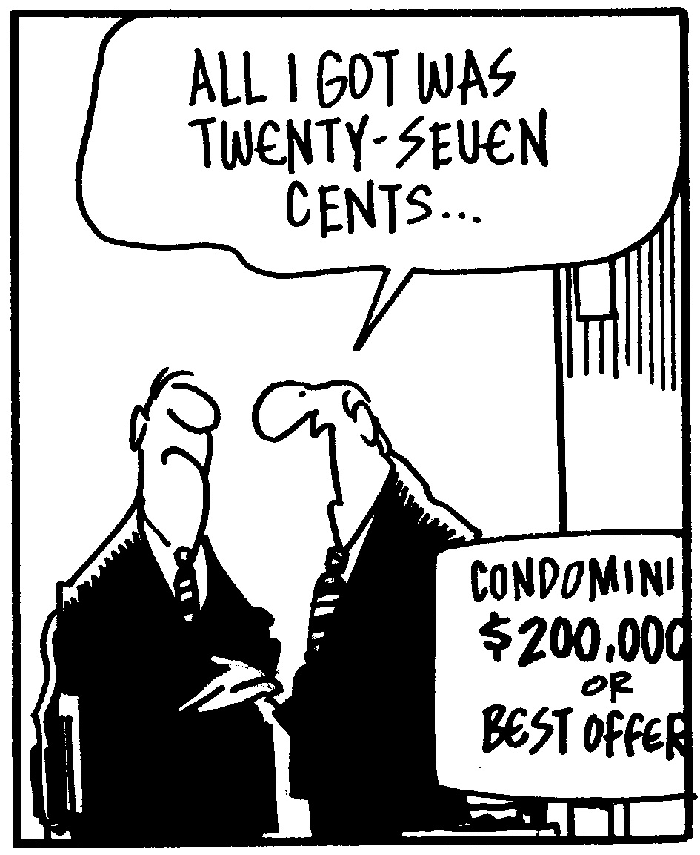



#### Selling St. Charles County News Tyme

### “Insider Tips For Healthy, Wealthy & Happy Living…”

**Joanna Horstmeier**

CDPE, CIPS, CRS, E-pro, GRI,

Broker Associate



**Getting Control Of Medical Debt**

First it starts with a doctor’s appointment, and then there’s the follow-up appointment, medication, and therapy. One medical expense can quickly turn into several, and one co-pay or bottle of pills can add up to thousands of dollars before you realize what has even happened.

Be proactive and start digging yourself out of that medical debt with these tips:

* **Communicate with your provider:** Upon receiving a medical bill, take action even if you can’t pay right away. Try to set up a payment plan allowing you to pay small increments of the bill over time. Many providers will hold out on sending bills to a collections agency if you proactively and consistently pay toward the amount owed.
* **Ask for an itemized bill:** Auditing everything on a medical bill helps demystify why you owe money and helps to clarify any mistakes and uncover fraud. If there is an expensive procedure on the bill you did not agree to (but were in a condition to understand throughout treatment), you can fight the charge.
* **Keep records:** Make copies of all canceled checks, receipts, and account statements. These things are needed if you have to dispute a credit report error. If speaking to someone in person or by phone, keep detailed records about every conversation.
* **Offer to pay a lump sum:** If you’ve been making consistent payments and the amount due finally reaches a point you can pay off, ask if you can pay remaining debt in one lump sum at a slightly lower amount than if you continued making ongoing payments.
* **Monitor medical debt on credit reports:** Medical debt can only be posted to a credit report after 180 days, so use this time to catch up on unpaid bills and correct discrepancies pending with insurance companies. If paid debt does appear on a credit report, take proactive steps to remove it. After contesting paid medical debt on your credit report, continue to monitor your report and follow up to ensure the debt is removed in a timely manner.



# How To Get Top Dollar Selling Your Home...

If you’re thinking about selling your home soon, request my Free Consumer Guide, “***7 Insider Tips To Net More Money Selling Your Own Home***.” This report will be your secret weapon to maximize the net profits from the sale of your home. You can get a free copy by calling me at…**636-970-0185**

**Help Kids Build Healthy Habits**

From choosing healthy meals to creating positive relationships, there are lots of little things adults can do every day to instill good habits in kids.

***Physical***

* Exercise regularly as a family, and make it fun! Go for evening walks in the park, take advantage of open swim days at the gym, and ride bikes together.
* Eat a healthy diet. Start early with introducing a rainbow of produce and minimizing sugary snacks.

***Mental***

* Maintain – and reflect – a positive outlook. Kids mirror what they hear and see, so use positive reinforcement and praise appropriately. Celebrate your successes as well as theirs.
* Keep screen time to a minimum. Sedentary behavior is known to increases risks for obesity and cardiovascular disease, and it’s not conducive to positive social or mental growth either. Set a daily limit for TV viewing, video games, and smartphone usage and stick to it.
* Read every day. Incorporate this habit into playtime or bedtime routines to help build self-esteem and success later in life.

***Social***

* Encourage kids to explore a myriad of activities to find one (or more!) they really enjoy. Whether singing in a choir, playing soccer, taking language lessons, or volunteering with a youth group, kids will meet others with similar interests while also developing their self-identity.
* Eat dinner as a family, and use this opportunity to maintain open lines of communication with everyone around the table.

**Word of the Month…**

Studies have shown your income and wealth are directly related to the size and depth of your vocabulary. Here is this month’s word, so you can impress your friends (and maybe even fatten your wallet!)…

**Pivot** (piv-et) verb

**Meaning:** A term now being used by job seekers to indicate consideration of a career change or professional direction. As a noun, it means a change in direction due to uncertain business conditions.

**Sample Sentence:** As a seasoned journalist, she wanted to pivot and use her professional skills in more of a marketing capacity.

**Finders Keepers**

Can’t find your keys (or another small object)?

* **Stay calm.** Look for the object where it’s supposed to be and in close proximity to that location.
* **Be systematic.** Thoroughly search a select area and then move on. Don’t re-search areas.
* **Search areas with clutter.** Prevent lost time by looking in areas where an item is easy to overlook among other items.
* **Retrace your steps.** Vividly try to walk through the actions, feelings, and context of when you last had the item.
* **Avoid creating a false memory.** If searching with someone else, ask open-ended questions – not questions like “Remember, we saw it in the hallway?”

**Banned Veggies**

Which vegetable was banned from the *Mayflower*?

The leek!

**Quotes To Live By…**

“I haven’t failed. I’ve found 10,000 ways that don’t work.”

–Thomas Edison

“Time you enjoyed wasting was not wasted.”

–John Lennon

“Be thankful for what you have and you will end up having more.”

–Oprah Winfrey



**Simple Relationship Tips**

A happy, healthy relationship with your significant other doesn’t ride on fancy flowers, heart-shaped chocolates, and an annual celebration on Valentine’s Day. In fact, sometimes it’s the small things that mean the most in a relationship with your loved one. Start small with these ideas.

**Set the smartphone down.** Offer your undivided attention with time set aside for the two of you – no phones allowed! Perhaps this is over dinner in the evenings, in the bedroom, or on a once-a-week date night out (or in).

**Say thank you.** Don’t take your partner for granted. Acknowledge and appreciate even the small things like cooking dinner or doing the dishes.

**Do something he/she likes to do.** Embrace your partner’s differences. Next time you choose a movie together or look for a weekend activity, get out of your comfort zone and try something that’s not generally your style. And, the time after that, encourage your partner to do the same.

**Dress up.** When you go out for a date night, dress up. Don’t fall into the familiar comfort rut. Keep things fun with a little flirtation.

Brain Teaser…

There was a plane crash, and every single person on board died. Yet, two people survived the crash. How?

*(See page 4 for the answer.)*

**What’s My Home Worth?**

If you want to know your home’s current value, I will gladly conduct a ***Maximum Value Home Audit***. Request this “no charge” in-depth home value analysis by calling me at: **636-970-0185**

**Quiet The Kitties**

Does your cat incessantly scratch and meow once you’ve closed the bedroom door at night? Put an end to it!

* Make sure there are no underlying medical issues that are causing late-night disturbances.
* Encourage activity in the evening to help tire the cat out.
* Place a deterrent such as aluminum foil, sticky tape, or a tray of rocks in front of the closed door.
* If space allows, set up a cozy room specifically for the cat.
* Do NOT give in to the scratching and meowing. That just reinforces the bad habit.

**Side Stitch?**

Nothing cramps a run like the dreaded side stitch. If one sneaks up on a run, slow the pace and exhale as the foot on the opposite side of the stitch hits the ground. It’s unnecessary to do this on every exhale, but sync up the breath and foot strike to alleviate the cramp.

**Home Workout Websites**

Don’t have time to make it to the gym? DIY with a home workout!

**www.YogaDownload.com** – Offering thousands of yoga classes in a variety of styles.

**www.FitnessBlender.com** – Choose the perfect workout based on training type, equipment, time available, and difficulty level.

**www.YouTube.com** – There are thousands of fitness-related YouTube channels. Search for the kind of workout you want to narrow options.

Here’s A Free, Valuable Resource…

Now You Can Search The Home Market, Get Helpful Community Information, AND Receive Important Resources For Saving Time And Money When Buying Or Selling At **www.SellingStCharlesCounty.com**

**Keeping The Kitchen Organized**

From that first bowl of cereal to the final midnight snack, kitchens are among the most used rooms in the house. Organize it now to make it easy to get around and find what you need later.

* **Separate dedicated areas.** Keep areas for prepping, cooking, and storing food, and then keep similar items – such as baking equipment – together within each of these places.
* **Store items in clear containers.** Small items like tea bags and gravy mixes should be stored with like items in a storage unit that can be easily identified with a quick peek.
* **Invest in risers and drawer dividers.** It’s much easier to access cookware and dishes in cabinets if they’re sorted and stacked on risers. Ditto for small items separated using drawer dividers.
* **Think seasonally.** If you don’t use that crock pot in the summer or the ice tea container in the winter, tuck them out of sight and out of mind until the proper season rolls back around.
* **Look for a lazy Susan.** On countertops, they can be used for oils, spices, and other ingredients you might need at a moment’s notice. And in the pantry, use them to store cans, jars, and condiments.

**Thanks For Thinking of Me!**

Did you know I can help you or any of your friends or family save time and money when buying or selling a home? Thanks for keeping me in mind with your referrals…and spreading the word about my services.

**Brain Teaser Answer:**

The plane crash survivors were married.

**Give With Confidence**

**GoFundMe.com** is a fundraising site for people and projects raising money in the face of natural disasters, personal calamities, or other financial problems. Unfortunately, there are some unsavory folks hoping to claim money as well. Here’s how to know your money is funding a legitimate purpose:

* Avoid campaigns with minimal information about specific issues or financial problems.
* Perform a reverse image search on Google. Right click on the main photo and select “Search Google for Image.” If there are a lot of results, the photo was stolen and the campaign likely isn’t real.
* Contact the fundraiser. Click on the little green envelope to send an email if you want clarification or have questions.

**THANK YOU** for reading my

personal newsletter. I wanted to produce a newsletter that has great content and is fun and valuable to you. Your constructive feedback is always welcome.

**AND…**whether you’re thinking of buying, selling or financing real estate, or just want to stop by and say “Hi,” I’d love to hear from you…

**Joanna Horstmeier**

**CDPE - CIPS – CRS – E-pro –GRI**

**And Broker Associate**

**Remax Results - 636-970-0185**

[***Joanna@SellingStCharlesCounty.com***](mailto:Joanna@SellingStCharlesCounty.com)

Disclaimer: The information contained in this letter is intended for informational purposes. It should not substitute as legal, accounting, investment, medical or other professional services advice. Always seek a competent professional for answers to your specific questions. This letter is not intended to solicit real estate properties currently for sale.

**“Who Else Wants To Win**

**A Starbucks Gift Card?”**

Last month must have been a tough question……no winners!

Let’s see if we can get one this month!!!

**In what 2011 noir movie was Hugh Jackman replaced by Ryan Gosling?**

a) Crazy, Stupid Love b) The Ides of March c) Stay

d) Drive

The answer is d) Drive. Ryan Gosling also brought on a new director for the movie, Nicolas Winding Refn. So let’s move on to *this* month’s trivia question.

**A set of twins born in 2013 named Amy and Katie   
 set a world record. Why?**

a) Conjoined at the feet b) Longest amount of time between births c) Most amount of hair d) Born on different continents

***Call Me At 636-970-0185 OR Email Me At*** [***Joanna@SellingStCharlesCounty.com***](mailto:Joanna@SellingStCharlesCounty.com)

***And You Could Be One Of My Next Winners!***

***Real Estate Corner…***

**Q. Why is it important to do a walk-through before closing on a home?**

**A.** You need to do a walk-through with your REALTOR® typically within 24 hours of your closing to make sure the home is in the condition specified in the contract.

You’ll want to look at each room (which now should be empty and clean), examine the hardwood floors, check the ceilings for leaks (in case there has been a recent storm), test the windows, turn on the appliances etc. to ensure there aren’t any surprises. You also want to check on the completion of any negotiated repairs or replacements that you and the seller agreed upon.

If you find any problems, your REALTOR® will help you determine what you should pursue (such as possible new leak under the sink) with the seller or what you can handle yourself.

If you’re buying a new home, you need to visit the property with the builder’s representative and create a “punch list” of items that are not completed to discuss at closing. You should get a written confirmation on when the builder will complete those items.

To learn more about buying a home for the first time, ask for my Free Consumer Report called **“Top 10 First-Time Homebuyer Mistakes To Avoid. ”**  I’ll send a copy right to you.

Do you have a question related to real estate or home ownership? Please call me at **<<your number>>.** Perhaps I’ll feature your question in my next issue!