*Buying A Home Soon? Get my Free Consumer Guide, “8 Secrets For Saving Thousands When Buying Your Home.” Call me right now at 636-970-0185 for details…*

# 

# March 2018

**St. Charles, MO**



## Inside This Issue…

**How to Make an “In Case of Emergency” File…Page 1**

**Camping Safety Tips…Page 2**

7 Easy Ways to Improve Your Car’s Fuel Economy…Page 2

Choosing the Right Tree for Your Yard…Page 3

**Answer This Trivia Question and You Could Win a FREE Car Wash...Page 4**

**How Do I Set the Right Price to Sell My Home?...Page 4**

#### Selling St. Charles County News Tyme

### “Insider Tips For Healthy, Wealthy & Happy Living…”

**Joanna Horstmeier**

CDPE, CIPS, CRS, E-pro, GRI,

Broker Associate







**How to Make an Emergency File**

If something happened to you today, would your loved ones know where to find all your important information and documents? Setting up an ICE file – an “in case of emergency” file – gives everyone peace of mind in the event of the unexpected.

**What goes in your ICE file:**

* Legal and financial documents – Including your will, power of attorney, medical directive, health records, social security card, marriage certificate, military records, home and car titles, mortgage, insurance policies, credit cards and investment records.
* Copies of identification documents – Such as your passport, driver’s license, and birth certificate.
* Emergency contact information – Including your lawyer, accountant, investment manager, insurance agent, and doctors.

**Storing and sharing your ICE file:**

* A small, fire-proof safe is an inexpensive option for storing all your documents at home. For added security, ask your bank about a safety deposit box. (Remember to make a copy of any keys for your loved ones to access the file.)
* Though some information can be stored online for ease of access with solutions like Google Drive or Dropbox, it’s probably best to store less sensitive documents there, such as contact information.
* Talk to your loved ones about the ICE file – where it is, what’s in it, and who has access.
* Make sure your lawyer, accountant, investment manager, and insurance agent all know to whom they’re allowed to divulge personal information.

**What about passwords?**

Password security is on everyone’s minds lately. Keep yours safe, even with your ICE file, by storing them in a password manager (like **1password.com** or **LastPass.com**) and giving emergency access to a trusted person. You can also export passwords securely into an encrypted file, which can then be shared safely.

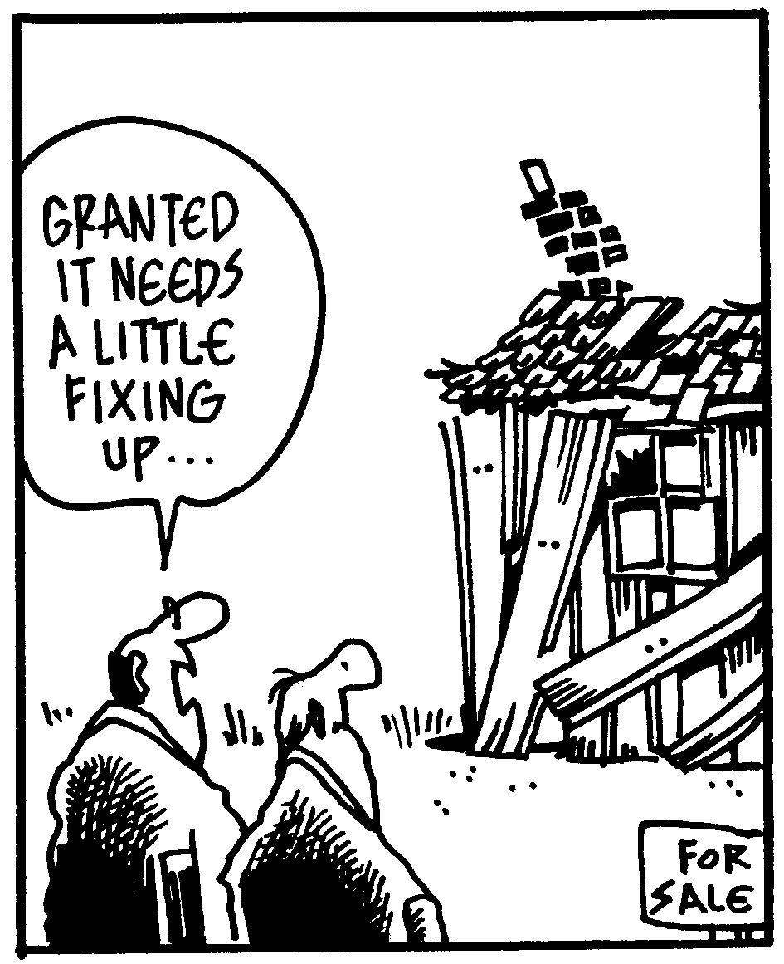

**Thinking Of Buying A Home Soon?**

If you’re planning to buy a home in the next 6 months, you’ll want a copy of my Free consumer guide, “***7 Secrets For Saving Thousands When Financing Your Next Home****.”* My report will help you avoid frustrations and costly pitfalls when buying a home. Simply call me to get a free copy: **636-970-0185**

**Camping Tips: Safety First**

There’s nothing like a camping trip to truly get away from it all. Make your next camping adventure more calm than calamitous with these important safety tips.

* Know the weather forecast, current fire danger level, and how to handle local insects and wildlife you might encounter.
* Ask for tips, information, and any current warnings from park staff.
* Prepare for the elements with sunscreen and a wide-brimmed hat in hot weather and warm layers in cold weather.
* Bring a first-aid kit and insect repellent and be prepared for emergencies.
* Pack plenty of water (or a way to purify water) and stay hydrated.
* Allow at least two hours of daylight to scout a safe spot and set up camp.
* Practice fire safety. Never cook in an enclosed space (carbon monoxide is odorless) or leave a fire unattended.
* Learn how to store food overnight to keep wildlife at bay.
* Know how to properly strike your camp, leaving no trash behind.
* Notify someone of where you’ll be and when you plan to return, especially if you’re camping solo or will be out of cell phone range.

**Word of the Month…**

Studies have shown your income and wealth are directly related to the size and depth of your vocabulary. Here is this month’s word, so you can impress your friends (and maybe even fatten your wallet!)…

**Plandid** (PLAN-did) noun, portmanteau of “planned” and “candid”

**Meaning**: A photo, often on Instagram, which is meant to look candid but is actually carefully planned.

**Sample Sentence:** Perfect makeup, hair, and lighting in that supposedly casual celebrity photo are dead giveaways it’s a plandid.

**5 Clever Camping Hacks**

1. Bring toilet paper in a large coffee can or a 2-liter bottle to keep it dry.
2. Store matches in a canning jar with a sandpaper lid for striking.
3. Use a hanging shoe organizer to store camp cooking supplies.
4. Wrap duct tape around your flashlight handle instead of bringing an entire roll of tape.
5. A pop-up laundry hamper makes an instant trash can.

**Car Cleaning Made Easy**

* Dryer sheets remove dead bugs from the front of your car.
* You can use toothpaste and water to shine a car’s headlights.
* A plastic cereal storage container with a pop-up lid makes a perfect car trash can.
* Try a cheap foam paintbrush to clean dust from AC vents.

**Quotes To Live By…**

“In every walk with nature one receives far more than he seeks.”

–John Muir

“The problem with having a sense of humor is often that people you use it on aren’t in a very good mood.”

–Lou Holtz

“This is the precept by which I have lived: Prepare for the worst; expect the best; and take what comes.”

–Hannah Arendt

**DID YOU KNOW**…

Unlike most real estate agents, I *DON’T* spend my time pestering people with phone calls or bothersome interruptions to find good clients. Instead, I dedicate 110% of my time and energies to providing such outstanding service, people naturally think of me when a friend or family member needs help buying or selling a home. THANKS for your referrals!

**FREE Consumer Help Is Just A Phone Call Away**

Learn valuable secrets for saving thousands and avoiding costly mistakes when buying, selling or refinancing a home. Best of all, it’s FREE. Ask about my “**Insider’s Free Resources**” by calling me at: 636-970-0185

**Improve Fuel Economy Easily**

No matter how much you drive, improving fuel economy saves money and the environment. Here are some easy ways to make a tank of gas go further.

* **Keep Tires Properly Inflated** – Check your tires weekly and inflate to recommended levels.
* **Slow Down** – Going the speed limit uses less fuel (a highway speed of 65 instead of 75 mph can use up to 15% less fuel).
* **Change Speed Gradually** – Sudden braking or acceleration uses much more fuel than increasing or decreasing speed in a gradual way.
* **Don’t Let the Engine Idle** – If you’ll be stopped for more than a minute, shut your car off rather than letting it idle.
* **Combine Trips** – Map out a sensible route for errands and do them in succession rather than going back and forth across town.
* **Reduce Drag** – When you’re not using the roof rack to haul camping gear or a bicycle, taking it off makes your car more aerodynamic.
* **Perform Regular Maintenance** – Regular oil changes, new air filters, and spark plugs all help your car run more efficiently.

B

**What Tree is Right   
for Your Yard?**

Trees are a major landscaping feature for your home, and a major investment as well. Choosing the right tree for your yard is about much more than just what looks pretty in the garden center. Consider these factors before you start planting.

**What is the tree’s job?**

You might want property border definition, a privacy screen, shade, brilliant fall colors, or fruit growing in your yard. Narrow your search to trees that fulfill your needs.

**What trees are best suited to your location?**

Don’t invest in a beautiful tree if it won’t thrive in your climate or the soil in your yard. Also keep in mind how much extra watering a tree will need, and when. Trees generally need more water in the first two years before they’re established.

**What kind of maintenance is involved?**

Leaves that turn bright colors every fall may be a vibrant focal point for your garden, but those leaves will also need to be raked up. Find out what a tree will need in each season, including any pruning and disease prevention.

**How much space can the tree occupy?**

Be aware of how large a tree will get when it’s mature, and plant accordingly. Even if you won’t be in your house 20 or 50 years in the future, careful planting today means future occupants won’t need to uproot the tree.

The Arbor Day Foundation has a helpful “Tree Wizard,” where you answer some questions to find out what types of trees are right for you. (**https://www.arborday.org/shopping/trees/treeWizard/intro.cfm**)

Brain Teaser…

What asks but never answers?

*(See page 4 for the answer.)*

**Real Estate Question?**

Maybe you want to know how much your home is worth. Or maybe you just need a recommendation for a handyman, carpet cleaner or plumber…

Either way, I love hearing from all of my good friends and clients. And I’m happy to help answer questions you might have about anything relating to real estate or home-ownership.

If you have a question, tip or idea, call me at **636-970-0185.** I’m here to help!

**Plants as Mosquito Repellents**

Help keep annoying mosquitoes away from your backyard activities by planting the following fragrant species around your yard:

* Rosemary
* Lavender
* Citronella
* Catnip
* Marigold
* Lemon Thyme
* Lemon Balm

**Free Book Websites**

Add free eBooks or audio books to your virtual library from these excellent online resources.

**www.gutenberg.org** – Choose from more than 54,000 free eBooks on Project Gutenberg, including famous and classic works of literature. Download books or read them online.

**www.manybooks.net** – Browse through Many Books’ listings of more than 33,000 eBooks. The site includes both popular new titles and classics. Many are available for free, others are offered at a steep discount.

**www.librivox.org** – If you prefer listening to books, check out LibriVox for a wide selection of audiobooks. Titles are read by volunteers – and, yes, you can volunteer to become a reader, too.

1



**Thanks For Thinking of Me!**

Did you know I can help you or any of your friends or family save time and money when buying or selling a home? Thanks for keeping me in mind with your referrals…and spreading the word about my services.

**Brain Teaser Answer:**

An owl!

**DIY Homemade Ice Packs**

Mix one part rubbing alcohol with three parts water inside a sturdy zip-top bag and store in the freezer. The mixture will get very cold but not freeze completely, making it easy to mold over any aching joint.

You can also fill an old (clean!) sock with dry rice. Storing it in the freezer makes it an “ice” pack. Microwaving it carefully for a minute or two means it gives off soothing warmth.

**I Just Hear Desserts…**

**He**: “The weather is just wonderful. Shall we go for a jog?”

**She**: “Oh, dear, I’ve always liked how you pronounce, ‘Shall we go for dessert?’ ”

**THANK YOU** for reading my

personal newsletter. I wanted to produce a newsletter that has great content and is fun and valuable to you. Your constructive feedback is always welcome.

**AND…**whether you’re thinking of buying, selling or financing real estate, or just want to stop by and say “Hi,”  
 I’d love to hear from you…

**Joanna Horstmeier**

**CDPE - CIPS – CRS – E-pro –GRI**

**And Broker Associate**

**Remax Results - 636-970-0185**

[***Joanna@SellingStCharlesCounty.com***](mailto:Joanna@SellingStCharlesCounty.com)

Disclaimer: The information contained in this letter is intended for informational purposes. It should not substitute as legal, accounting, investment, medical or other professional services advice. Always seek a competent professional for answers to your specific questions. This letter is not intended to solicit real estate properties currently for sale.

**“Who Else Wants To Win**

**A FREE CarWash?”**

Last month must have been a tough question……no winners!

Let’s see if we can get one this month!!!

**A set of twins named Amy and Katie, born in 2013,   
set a world record. Why?**

a) Conjoined at the feet b) Longest amount of time between births

c) Most amount of hair d) Born on different continents

The answer is b) longest amount of time between births. Katie was born 87 days after Amy! So let’s move on to *this* month’s trivia question.

**What is the geographical term for a relatively shallow body of water separated from the open sea by a barrier?**

a) Lake b) Loch c) Lagoon d) Lacrosse

***Call Me At 636-970-0185 OR Email Me At*** [***Joanna@SellingStCharlesCounty.com***](mailto:Joanna@SellingStCharlesCounty.com)

***And You Could Be One Of My Next Winners!***

***Real Estate Corner…***

**Q. How do I set the right price to sell my home?**

**A.** Like many home sellers, you might have a price in mind that is too high. You need the knowledge of a REALTOR**®** to give you a more realistic opinion. Here’s what you should do:

* **Ask your REALTOR® for a “total market overview.”** What’s happening in general in the economy and the real estate market?
* **Get the facts for your neighborhood.** What homes have or haven’t sold in the last 6-12 months, and did the sales include short sales or foreclosures?
* **Work with your REALTOR® to set the right price from the start.** If you start too high, you may keep buyers away. If you lower your price in increments, it may be too late. Timing is key and buyers may already have purchased another home.

Would you like more information on selling your home? Call and ask for my Free Consumer Report called **“6 Steps For Selling Your Home For TOP DOLLAR.”** I’ll send a copy right to you.

Do you have a question related to real estate or home ownership? Please call me at **636-970-0185.** Perhaps I’ll feature your question in my next issue!