*Here’s free advice if you’re buying or re-financing your home. It’s my Free Consumer Guide titled, “7 Secrets For*

*Saving Thousands When Financing Your Home.” Call me at 636-970-0185 to get a copy…*****

# June 2018

**St. Charles, MO**

## 

## Inside This Issue…

**Easy Ways to Practice Gratitude…Page 1**

**Tips for Stress-Free Customer Service Interactions…Page 2**

**Supplements That May Help Prevent Alzheimer’s…Page 3**

**How to Clean a Yoga Mat…Page 3**

**Answer This Trivia Question and You Could Win a FREE PIZZA…...Page 4**

**I’ve Been Renting and I Want to Buy. Should I Get Pre-approved for a Mortgage?...Page 4**



#### Selling St. Charles County News Tyme

### “Insider Tips For Healthy, Wealthy & Happy Living…”

**Joanna Horstmeier**

CDPE, CIPS, CRS, E-pro, GRI,

Broker Associate





**How to Be More Grateful**

We would all rather be happy if given the choice. In some cases, our state of happiness can be a conscious choice we make to focus on the positive things in our lives. Learning to be grateful in your daily life is a surprisingly effective way to improve your health and overall happiness.

The benefits of being grateful can be huge. Studies show that people who are more grateful sleep better, feel healthier, have higher self-esteem, have more energy, and experience less stress. Staying grateful isn’t always easy, but with all these physical and mental benefits it’s absolutely worth the investment of your time.

Here are some easy ways to practice gratitude on a regular basis. Try out a few of them to see which suits you best.

* Keep a “gratitude journal” to jot down 1-2 things you’re grateful for daily.
* Actively work on cultivating positivity by looking for a bright side to negative situations.
* Pay someone an unexpected compliment each day.
* Talk about 2-3 positive moments from the day during nightly dinner conversation.
* Offer a heartfelt – not routine – “thank you” for a mundane task, such as someone holding a door open for you at the store.
* Say out loud what you’re grateful for, even if you’re talking to yourself.
* Put a picture of your family, or whatever you’re most thankful for, somewhere you’ll see it multiple times a day.
* Donate your time to a favorite cause. Monetary donations are great, but donating your time is even more effective at making you feel grateful.

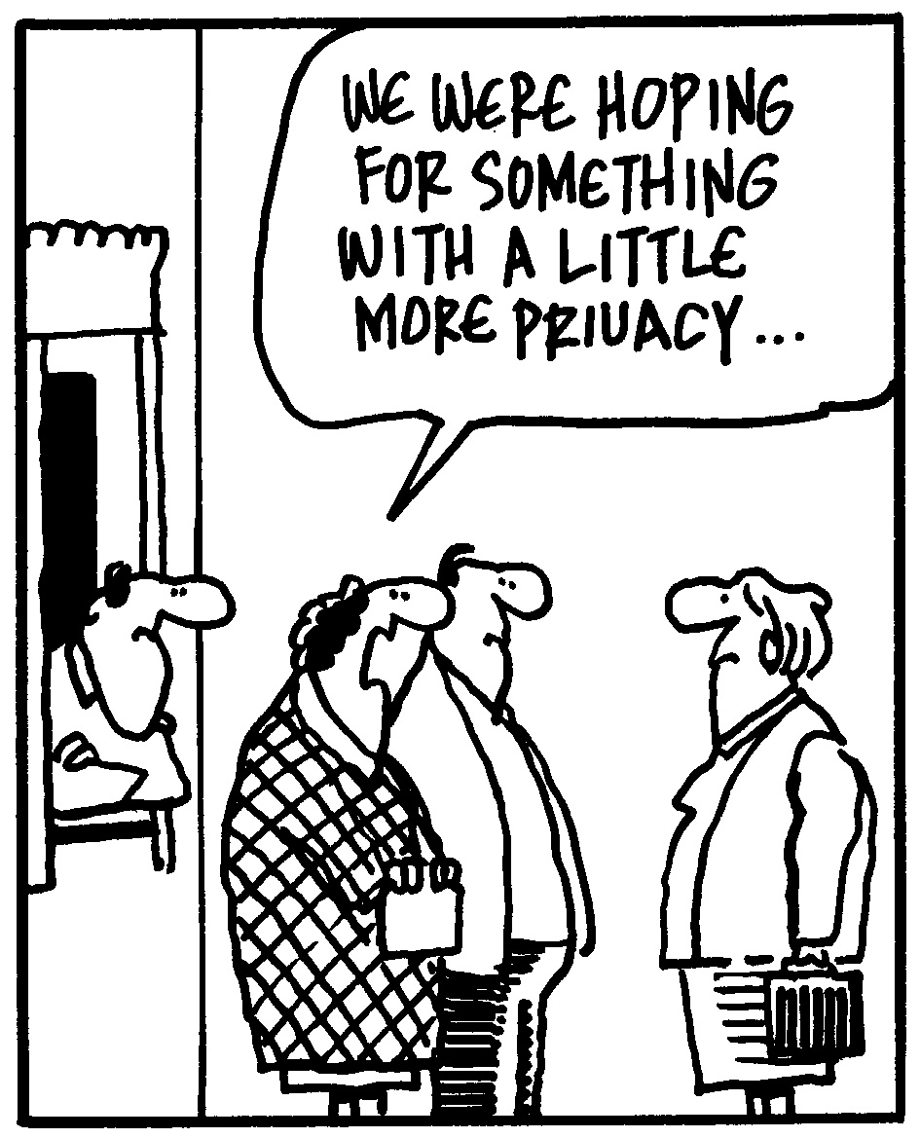

**Warning Before You Sell Your Home...**

Don’t put your home on the market without my Free Consumer Guide titled, “***How To Avoid 7 Costly Mistakes When Selling Your Home***.” My exclusive report will give you all the facts for a fast, top dollar sale. Just call **636-970-0185** anytime, 24 hours, and I’ll rush a copy out to you for free.

**Customer Service Tips**

While calling customer service may strike fear into the hearts of many, there are simple ways to help make sure your next call to a help line or shop returns counter is less stressful and more successful.

**Be Prepared**

Gather all the documentation you think you’ll need before you begin. Err on the side of over-preparing so you won’t be even more frustrated by having to make the same trip or call a second time.

**Be Nice**

Remember the person to whom you’re talking is a human being who isn’t responsible for whatever problem you had with their product or service. Kindness will always get you further than starting off with anger.

**Be Patient**

Sometimes your problem can be fixed quickly. Sometimes it can’t. Don’t start a customer service call when you’re pressed for time, or the ticking clock will make the experience worse.

**Be Direct**

Explain your issue briefly and ask for what you need as plainly as possible. If you can, suggest a solution that works for you.

**Be Recording**

Companies often record customer service calls, and you can, too. It’s easiest to do this with a live chat on a company’s website, which you can copy and paste into a document or email to yourself.

**Word of the Month…**

Studies have shown your income and wealth are directly related to the size and depth of your vocabulary. Here is this month’s word, so you can impress your friends (and maybe even fatten your wallet!)…

**JOMO** (joe-moe) acronym, stands for “joy of missing out”

**Meaning:** You’ve probably heard of FOMO, the fear of missing out. This is its opposite – when you’re happy to stay in when others are going out.

**Sample Sentence:** I'm experiencing some serious JOMO because I stayed in to watch Netflix tonight.

**Shower Organization Hacks**

Streamline your morning routine with these clever organization tips.

* Mount a coat hook opposite the shower spout. Hang your shower caddy there to keep it out of the way.
* Put a tension rod on the inner wall of your tub to hang multiple shower caddies. Great for big families.
* Get a mesh shower pocket organizer to hang on the inside of your shower curtain using the same hooks.

**Preserving Fresh Basil**

Save those fresh basil leaves before they rot and end up in the trash!

* **In the fridge:** Layer clean, dry basil leaves in a jar with a little salt and olive oil. Make sure all the leaves are submerged. This lasts in the fridge for about a year.
* **In the freezer:** Put basil leaves and water in ice cube trays or other small containers. Store the frozen blocks in a zip-top bag. Melt the ice to use the basil.

**Quotes To Live By…**

“Some people grumble that roses have thorns; I am grateful that thorns have roses.”

–Alphonse Karr

“Patience is not simply the ability to wait – it’s how we behave while we’re waiting.”

–Joyce Meyer

“Happiness is nothing more than good health and a bad memory.”

–Albert Schweitzer



**Can Supplements Prevent Alzheimer’s?**

Exercise, a healthy diet, social engagement, and mental stimulation can all be extremely helpful in preventing Alzheimer’s disease or delaying its onset, as these things all help keep the brain healthy. Some studies are also looking at supplements that may help in that effort.

* **Folic Acid:** Taking folic acid helps reduce homocysteine levels, which can lower your risk for both memory loss and heart disease.
* **Vitamin B12:** There’s some support for a correlation between higher levels of B12 in the blood and lower incidence of dementia diagnosis. Like folic acid, B12 helps reduce homocysteine.
* **Omega-3 Oil:** Adding fish (such as salmon, tuna, and trout) to your diet is an easy way to get more of these healthy fats into your system, and fish oil is also available as a supplement.

Talk to your doctor before you begin any new regimen of supplements.

Brain Teaser…

What has six faces, 21 eyes, but still can’t see?

*(See page 4 for the answer.)*

**What’s My Home Worth?**

If you want to know your home’s current value, I will gladly conduct a ***Maximum Value Home Audit***. Request this “no charge” in-depth home value analysis by calling me at: **636-970-0185**.

**How to Sleep on Planes**

* Turn your neck pillow around with the open part in back so your head won’t bob forward while you sleep.
* Skip alcohol, caffeine, and sugar from the beverage and food carts.
* Use an eye mask to block light.
* Listen to white noise (try TMSoft’s “White Noise” App) to drown out passenger and plane sounds.

**Cleaning Your Oven Door**

Even with a self-cleaning oven, the glass in the oven door never sparkles. It’s easy to clean with **baking soda and water**. Simply spread baking soda over the inside of the glass with the door lying flat open and spray all over the baking soda with water. Let it sit for a minute or two (longer if the glass is really dirty) and wipe away with a damp cloth. Easy and chemical-free!

**Meditation Websites**

Meditating for even a few minutes can relieve stress, help you sleep, and improve your mood. Here are some guided meditation sites to try.

**www.marc.ucla.edu/mindful-meditations** – UCLA’s Mindful Awareness Research Center has several free guided meditations you can download, including some in Spanish.

**www.calm.com** – There is a Calm app, but the website also features some guided meditations (some free) to both help you relax and be more productive.

**www.meditationoasis.com** – There are meditations to listen to at Meditation Oasis, via the app, website, or podcast. The site also features meditations you can read.

**DID YOU KNOW**…

Unlike most real estate agents, I *DON’T* spend my time pestering people with phone calls or bothersome interruptions to find good clients. Instead, I dedicate 110% of my time and energies to providing such outstanding service, people naturally think of me when a friend or family member needs help buying or selling a home. THANKS for your referrals!

**FREE Consumer Help Is Just A Phone Call Away**

Learn valuable secrets for saving thousands and avoiding costly mistakes when buying, selling or refinancing a home. Best of all, it’s FREE. Ask about my “**Insider’s Free Resources**” by calling me at: 636-970-0185

**Keeping Yoga Mats Clean**

You don’t leave your yoga pants unlaundered week after week, right? The same should be true of your yoga mat.

Luckily, a yoga mat is easy to clean – which is good, because it’s recommended to do so at least weekly. That changes to daily if you sweat profusely, do yoga outside, or use the mat regularly.

* **Vinegar is your friend.** Keep a 50-50 mix of water and white vinegar in a spray bottle (this is also useful for other household cleaning). You can add a few drops of tea tree or lavender essential oil if you like. Spray the mat lightly and wipe it down.
* **Keep it out of the sun.** It’s a good idea to leave your yoga mat out to air dry after you’ve wiped off the vinegar spray, just don’t leave it out in direct sunlight. The sun could permanently dry the mat out.

Opinions vary on whether a yoga mat will survive the washing machine, so check your mat for the manufacturer’s recommended cleaning methods first.

**“Who Else Wants To Win**

**FREE PIZZA?”**

Last month must have been a tough question……no winners!

Let’s see if we can get one this month!!!

**The “Strongest Girl in the World” (a fictional character) has a pet monkey named what?**

a) Bananas b) George c) Abu d) Mr. Nilsson

The answer is d) Mr. Nilsson, Pippi Longstocking’s pet monkey. Let’s move on to *this* month’s trivia question.

**What Major League Baseball player currently holds 5th place on the career home runs record list, behind Barry Bonds, Hank Aaron, Babe Ruth, and Alex Rodriguez?**

a) Albert Pujols b) Willie Mays c) Ken Griffey Jr. d) Jim Thome

***Call Me At 636-970-0185 OR Email Me At Joanna@SellingStCharlesCounty.com***

***And You Could Be One Of My Next Winners!***

**Thanks For Thinking of Me!**

Did you know I can help you or any of your friends or family save time and money when buying or selling a home? Thanks for keeping me in mind with your referrals…and spreading the word about my services.

**Brain Teaser Answer:**

Dice

**DIY Organic Fertilizers**

You don’t need to compost to turn kitchen scraps into excellent garden fertilizer. Here are three easy and chemical-free fertilizers you can make at home.

* **Coffee grounds** add much-needed nitrogen to soil, as well as acidity. Mix the grounds right into the soil around plants.
* **Banana peels** add potassium, phosphorus, and calcium to soil. Bury a peel (or a whole overripe banana) near plants that need those minerals.
* **Egg shells** are an excellent source of calcium. Boil egg shells in water and leave them to soak all day or overnight. Strain out the shells and spray the remaining water onto the soil.

**THANK YOU** for reading my personal newsletter. I wanted to produce a newsletter that has great content and is fun and valuable to you. Your constructive feedback is always welcome.

**AND…**whether you’re thinking of buying, selling or financing real estate, or just want to stop by and say “Hi,” I’d love to hear from you…

**Joanna Horstmeier**

**CDPE - CIPS – CRS – E-pro –GRI**

**And Broker Associate**

**Remax Results - 636-970-0185**

[***Joanna@SellingStCharlesCounty.com***](mailto:Joanna@SellingStCharlesCounty.com)

Disclaimer: The information contained in this letter is intended for informational purposes. It should not substitute as legal, accounting, investment, medical or other professional services advice. Always seek a competent professional for answers to your specific questions. This letter is not intended to solicit real estate properties currently for sale.

***Real Estate Corner…***

**Q. I’ve been renting and I want to buy a home. Should I get “pre-qualified” or “pre-approved” for a mortgage, and which is better?**

**A.** You can get a “pre-qualification” letter from a lender fairly easily after a 10-minute phone interview. However, you are in a stronger position to buy if you get a “pre-approval” letter, which means the lender has **verified** your income in terms of employment, funds on deposit, and your credit history.

Pre-approval may take a few days to a few weeks but it’s worth the effort since it tells the sellers you can get financing. All that remains is the property appraisal for you to get a home loan.

Want to learn more about buying a home for the first time? Call and ask for my Free Consumer Report called **“Top 10 First-Time Homebuyer Mistakes To Avoid.”** I’ll be glad to send a copy to you.

Do you have a question related to real estate or home ownership? Please call me at **636-970-0185.** Perhaps I’ll feature your question in my next issue!